Pro Stickers Online

Software Requirement Specification

V 1.7

June 13, 2017

Prepared by

Maeru Systems

# Revision History

|  |  |  |  |  |
| --- | --- | --- | --- | --- |
| **Date** | **Version** | **Description** | **Author** | **Comments** |
| 02-08-2017 | 0.1 | Created | CJ |  |
| 02-13-2017 | 0.2 | Updated | CJ |  |
| 02-14-2017 | 0.3 | Updated | CJ |  |
| 02-16-2017 | 0.4 | Updated | CJ |  |
| 02-17-2017 | 0.5 | Updated | CJ |  |
| 02-22-2017 | 1.0 | Make sticker price rate per inch editable by Admin/Master | VJ |  |
| 02-22-2017 | 1.1 | Deleted Section 3.2.13 b on Page 75 | MS |  |
|  | 1.1 | Section 3.1.7 reason for appointment cancellation is optional not mandatory (Page 17) | MS |  |
|  | 1.1 | Section 3.1.9 Purchase Option (Page 26) Master should be allowed to delete Vector File from a customer’s account. Customer and Designer should not be allowed to delete the vector file. | MS |  |
| 02-23-2017 | 1.2 | Section 3.2.6 aspect ratio is required whenever customer upload the vector file | VJ |  |
|  |  | Section 3.1.9 Purchase options - updated the price calculation formula for stickers provided by Aaron | VJ |  |
|  |  | Section 3.2.13 Removed the predefined size table for price calculation. Now it will be calculated based up the formula given in 3.1.9 | VJ |  |
| 04-18-2017 | 1.3 | Section 3.2.8/3.2.9 Order Tracking search filters added in master/designer roles. | SS |  |
|  |  | Section 3.2.12 Color Chart – Added Delete feature | SS |  |
|  |  | Section 3.2.12 Color chart – Active/Inactive Color feature is added. | SS |  |
|  |  | Section 3.1.12 Create Order – Color Selection with Selected Color (color box) having select/unselect functionality is added. | SS |  |
| 04-25-2017 | 1.4 | Section 3.2.6. Added text fields – Skype ID and Meeting Link in Customer Appointment details (access to Designer/Customer) | SS |  |
|  |  | Section 3.2.6 Added Designer’s note in Customer Appointment (access to Designer) and Customer Detail (access to master) | SS |  |
| 05-02-2017 | 1.5 | Section 3.2.1 Added active/inactive feature for users (master/designer) in place of Delete feature. User list, Edit User forms will have active/inactive features. | SS |  |
| 05-02-2017 |  | Section 3.2.1 Users (Active/Inactive) should not be read-only from list page. It should be a toggle switch to select (make active) deselect (make inactive) Page 52 | MVS |  |
| 05-16-2017 | 1.6 | More fields added in –   1. Order Detail (customer portal) 2. Update Tracking Number form (master/designer portal) 3. Customer Billing/Delivery Address – fields removed. 4. Design list – added one more column as Design image. 5. Updated few Mock up on (06-01-2017) | SS |  |
| 06-13-2017 | 1.7 | 1. Order Detail: Amount fields added  2. Update Tracking Number (Master/Designer): Amount fields added  3. Minor Label renamed (Contact Me as Connect Now)  4. Update: Connect now (Customer portal) – Queue Real time Sequencing technique. | SS |  |

# Approval History

|  |  |
| --- | --- |
| **Approved by** | **Approval date** |
|  |  |
|  |  |
|  |  |
|  |  |

**Table of Contents**

Revision History II

Approval History III

1. Introduction 1

1.1. Purpose 1

1.2. Scope 1

1.3. Definitions, Acronyms, and Abbreviations 1

2. Overall Description 1

2.1. Product Perspective 1

2.1.1. Master Web App 1

2.1.2. Customer Web App 3

2.2. Assumptions and Dependencies 3

3. Requirements 3

3.1. Customer Web App 3

3.1.1. Customer Sign In Form 3

3.1.2. Pro Stickers Service Terms and Privacy Policy 4

3.1.3. Customer Sign Up Form 5

3.1.4. Landing Page 7

3.1.5. Customer Profile/Account Detail, Edit 10

3.1.6. Upload Files/Add Notes 12

3.1.7. Appointments 13

3.1.8. Customer placing Call Request 19

3.1.9. Purchase Option 23

3.1.10. Payment and Shipping Option 29

3.1.11. Design 33

3.1.12. Order 34

3.1.13. Feedback Form 36

3.1.14. Connect Now button 37

3.1.15. View Designer Profile 38

3.1.16. Feedback Page 39

3.1.17. How it Works Page 39

3.1.18. Color Choices Page 39

3.1.19. About Us Page 40

3.2. Master and Designer Web App 40

3.2.1. Users 40



3.2.2. Master/Designer Sign In Form 45

3.2.3. Landing Page for Master 46

3.2.4. Landing Page for Designer 47

3.2.5. Add Availability Time 50

3.2.6. Customer’s Appointments 51

3.2.7. Customers 64

3.2.8. Order Tracking Information 67

3.2.9. Order Tracking Information 68

3.2.10. Feedback Form 69

3.2.11. Sales reporting functionalities 71

3.2.12. Product Color Chart 72

3.2.13. Product Size 74

4. WordPress Template 75

4.1. How it Works 75

4.2. About Us 75

# Introduction

Pro Stickers creates professional Emblem Overlays and Vinyl Decals from there shop. Customers walk to the mall store location and work with Pro Stickers’ designer to get their design done. Pro Stickers wants to build an online app which will allow their customers to build their design by collaborating with a designer on an idea or a concept online through Skype call.

## Purpose

This SRS describes the software functional and nonfunctional requirements of the **Pro Stickers Online App**. This document is intended to be used by the members of the project team that will implement and verify the correct functioning of the system.

## Scope

The scope of this project is to build an Online Web app which will allow the designer and customer to collaborate to create custom art work/design. Pro Sticker will use Skype to call the customers and share the desktop to collaborate. Pro Sticker Online Web App will allow Pro Stickers to manage designers, scheduling of designer’s time and manage their designs using the system. It will also allow customer to schedule the time with designers, upload their designs and work with designers on Skype call to complete the design. Once design is completed customer should be able to pay for the design vector files (and download it) and/or pay for the sticker/vinyl decal. Pro Stickers will ship the sticker/custom vinyl decal to customer. Time in Web App is in CST time format.

## Definitions, Acronyms, and Abbreviations

|  |  |
| --- | --- |
| **Term** | **Definition** |
| Master | Master and Admin are the same. Both the terms are interchangeable. |
| Designer | Designer, Employee and Customer Service Representative are the same. All the terms are interchangeable. |
| Customer  Web App | A web app where customer can come, create his/her profile and connect to Designer. |
| Master and Designer Web App | A Web application through which the Master access the customer’s account and Designer connect with customer to get the design i.e. art work complete. |

# Overall Description

## Product Perspective

The Pro Stickers Online web app is divided into two applications.

* + 1. Master Web App

This app will be used internally by Pro Stickers master and designers to manage the designers, customers and will be able to see the reports.

* The Master Web App will also allow the Master to create and manage Designer’s accounts.
* Provide access to Master so that they can access/edit customer’s account. All uploaded files should be accessible by any Master that pulls up customer account (name, email, phone number).
* Provide access to Designer so that they can add the files to the respective customer’s account with whom they are having the scheduled 15 minutes call.
* The Master Web App will allow the Pro Stickers Master and Designer to see all the customers’ request who have “Checked-In” online and requested to be called back.
* The designer should be able to invite the customer to connect to a Skype Meeting. Both customer and designer should be able to view real-time design changes, and exchange ideas/communicate while the design work is being created on Skype.
* Customer web app (Public Website) has some public pages and content of this pages can be changed by master using Master web app.
* Designer will manually initiate the call with Customer and update the call start time in the system. Also Designer will himself end the call with Customer and update the call end time in the system.
* Each design image and vector file will have unique id name and will be saved in customer account with the id name including respective customer’s id followed by year month date and time stamp. This year, month, date and time stamp is the one at which the designer has finished and uploaded the design.
* Figure 1 shows the context diagram of Master Web App

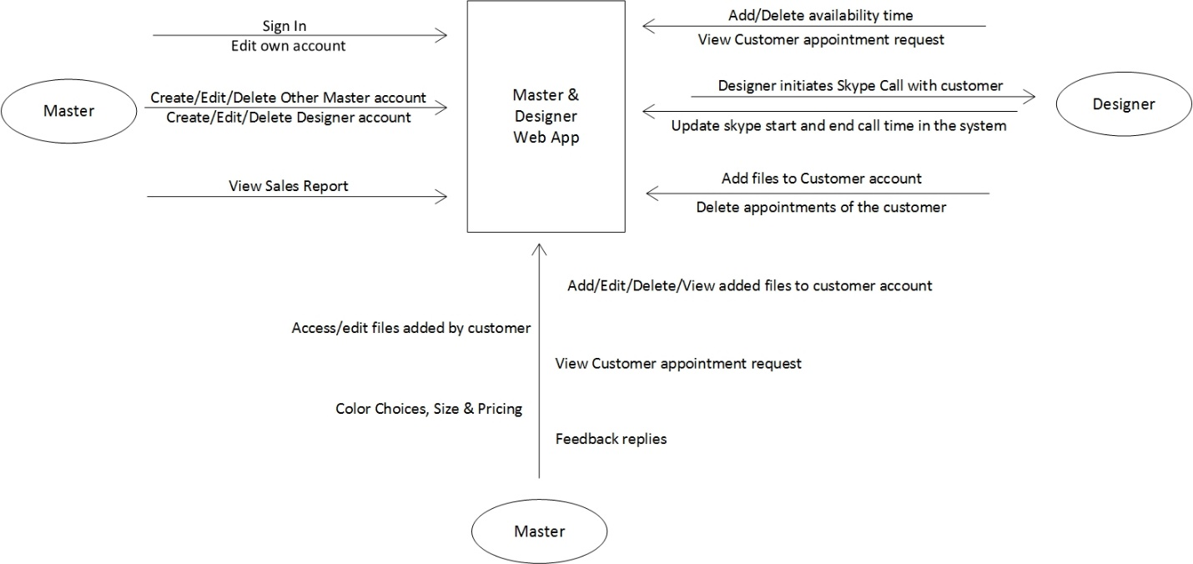

**Figure 1**

*Context diagram for Master Web App*

* + 1. Customer Web App

Customer Web App is a web application which provides the customers to register himself, order the design and see his/her old designs. It contains some public pages also.

* Customer can register him/herself.
* Customer can schedule appointment to connect live with a designer for creating the design.
* Allow customer to upload their own design, description files to their account.
* Customer can order for physical sticker by selecting the color and size of the vinyl and vector files also or he can order any one of these.
* Figure 2 shows the context diagram for Customer web app.

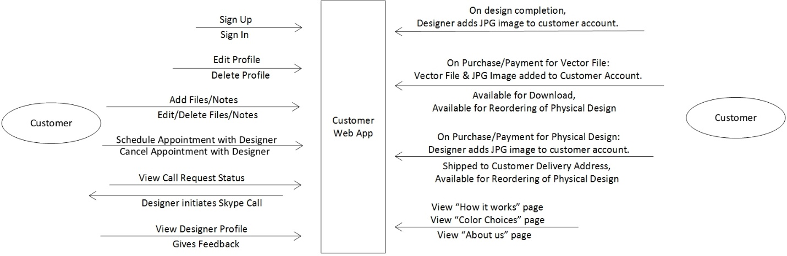

**Figure 2**

*Context diagram for Customer Web App*

## Assumptions and Dependencies

[TO DO]

# Requirements

## Customer Web App

* + 1. Customer Sign In Form

Customer sign in form i.e. through Google/Facebook will allow users to Sign in to the Customer Web App.

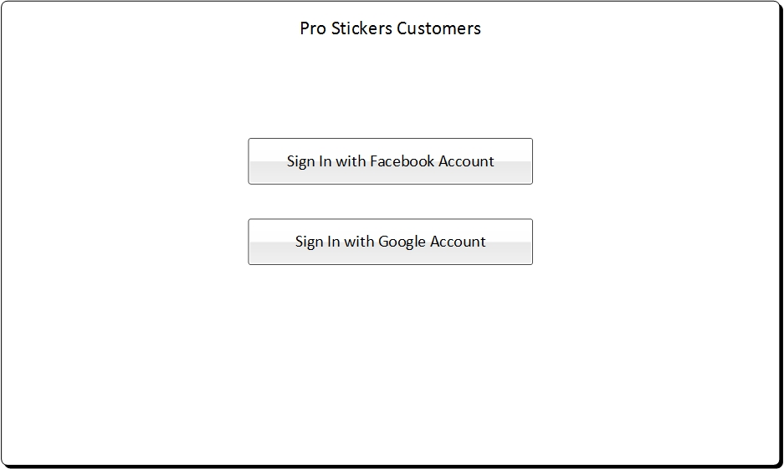

**Figure** *Sign In for Customers*

* + 1. Pro Stickers Service Terms and Privacy Policy
* Service Terms and Privacy Policy page will appear only once when the user sign in for first time.
* When I accept check box is checked then submit button will get enabled.
* MM/DD/YYYY is the date on which the customer is signing the terms and policy.
* Once submitted, terms and policy page will not appear again.

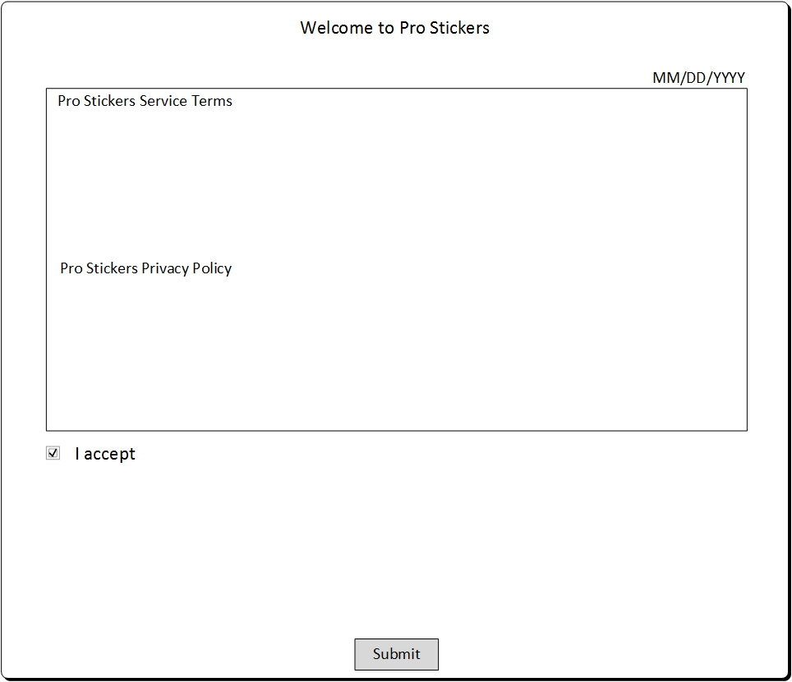

**Figure** *Pro Stickers Service Terms and Privacy Policy*

* + 1. Customer Sign Up Form

Every customer has to create his account before he starts ordering design. He can add billing and delivery address and can select default delivery address out of that.

* Customer has to create his/her profile and customer will sign up through his/her Google or Facebook Account.
* Google id for customers, masters and designers should be unique.
* Following information should be saved in customer account/profile:
* First name
* Middle name
* Last name
* Contact number
* Email
* Skype id
* Billing Address
* All the information including First name, Middle name, Last name, Contact number and Email will appear auto filled from Google/Facebook account through which the customer has sign in and is editable.
* Contact number is to be saved as per the selected country. This requirement is not needed now. Only maximum limit of 15 alphanumeric characters is needed.
* Billing address is not mandatory to fill but if customer adds any field in Billing address, then the fields including Location/Person name, Address line 1, City, State and Zip code is required.



**Figure** *Customer Profile (mock up – updated: 06/01/2017)*

* + 1. Landing Page

Once customer successfully Sign in, he will see the landing page and menu items to do all his work.

All the pages from 3.1.4 to 3.1.13 will be available only after the customer is signed in.

Customer will view the text header content for below:

1. Your Appointments:

* All the appointments that the respective customer has scheduled will appear here which are yet to be initiated.
* List contains: Appointment number (For each appointment, one unique appointment number is generated), Appointment date time and Requested date time.
* Drill down icon is present on appointment number on click of which customer will be redirected to respective Appointment Detail.
* On click of Connect Now button will place the customer request to be called back by the software. It will have the following details (Name, Email, Phone number - that is stored in profile details).

And Customer will receive the success message in the pop up that “You have been added to the queue. You are number <number # in which they are in the queue will appear> in the queue. Someone will contact you soon.”

* Customer can place one “Connect Now” request at a time till his/her request is not converted into the appointment. If customer tries to place another request, before his request converting in to the appointment then he/she will not be able to place the request and will get the message that “You are already added in the queue”.
* On click of Add Calendar Appointment, customer will be redirected to Add Calendar Appointment Page.
* On click of View More button, customer will get redirected to Appointments list page.

1. Your Orders

* Last 3 orders of respective customer will appear here (Last order will appear first).
* Drill down icon is present on Order number on click of which customer will be redirected to respective Order Detail.
* On click of View More button, customer will be redirected to the list page of all orders of him.

1. Your Design

* Last 3 created designs for respective customer will appear here (Last created design will appear first).
* Drill down icon is present on Design number on click of which customer will be redirected to respective Design Detail.
* On click of View More button, customer will be redirected to the list page of all the design images uploaded to his accounts.
* Design image for the top three designs will also appear as first column in the “Your Design”.

1. Your Files

* Last 3 uploaded files by respective customer will appear here (Last uploaded files’ name will appear first).
* On click of View More button, customer will be redirected to the list page of all uploaded files by him.

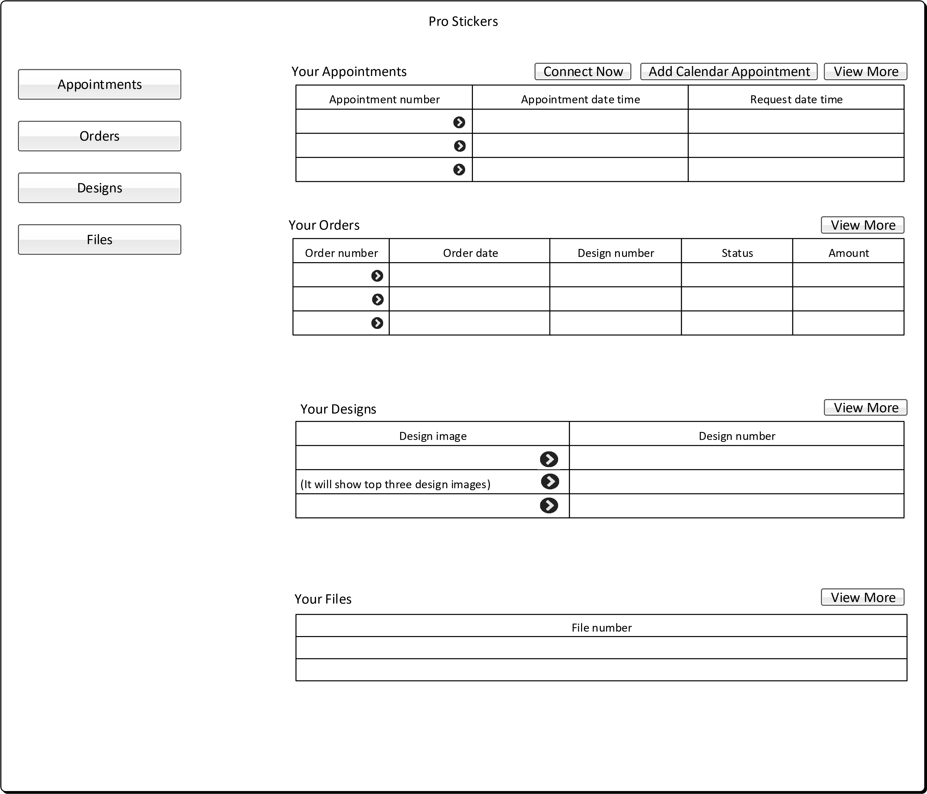

**Figure** *Customer Web App Landing Page (Mock up – updated on 06-01-2017)*

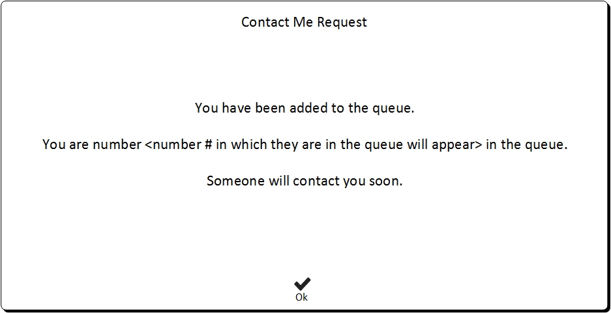

**Figure** *Pop up - Contact Me Request Success*

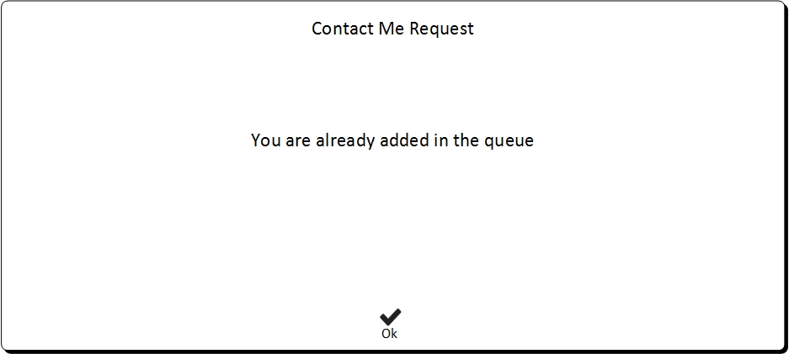

**Figure** *Pop up - Contact Me Request – Already Added Message*

* + 1. Customer Profile/Account Detail, Edit
* Customer should be allowed to view and edit all of their account information.
* Customer can view his account information from customer profile present on right hand corner.
* Customer can delete their own account/profile themselves.
* There will be no log maintained for the deleted customers. There will be no log of deleted design files/uploaded files once customer delete them from their account.
* Customer data should not be deleted from the backend system and only their status should change to deleted customer. Customer data will be required if order has been placed and designer has worked for that customer.
* Contact number is to be saved as per the selected country. It is not required to save contact number as per the selected country. Maximum 15 digits (alphanumeric) is set for entering contact number.
* Billing address is not mandatory to fill but if customer adds any field in Billing address, then the fields including Location/Person name, Address line 1, City, State and Zip code is required.
* Customer can also add/edit own Skype Id anytime in his customer profile form (Customer portal)
* Location/ Person Name field has been removed from the Billing Address, Delivery Address section (in Customer Profile form, Customer Detail form, Appointment Detail form)
* Neighborhood field is also removed from the respective forms.
* Country Drop down is set as first field in Billing Address section (in Customer Profile, in Customer Detail form). It is also set as first field in Delivery Address in Create Order (customer portal).



**Figure** *Customer Profile (Mock up Updated: 06/01/2017)*

* + 1. Upload Files/Add Notes

Customer can upload their own design files and notes.

* List page will be created for all the added files.
* Adding files and notes is optional for the customer.
* Customer can only delete the respective uploaded files and notes/comments. Customer has full control of deleting their own files at any time, regardless of design being complete or work being done.
* In order to make sure that customer does not intentionally or inadvertently delete their own data files, there needs to be a confirmation box asking “Are you sure you want to delete?” so that files are not deleted my mistake.
* This deletion by Customer will permanently delete the files from the Customer/Pro Stickers account.
* If customer chooses not to delete the documents, files including documents and notes/comments should remain in account unless deleted by customer.
* Uploading process should be simple clickable icons showing the files uploaded, either image or text file. When it is clicked by the designer, he should be able to see the uploaded file.
* For the customer it should be a simple upload file button with the limit to upload up to total of 10 Files OR Total of 20 MB, when either one of the limit is reached, Pro-Stickers’ customer will not be allowed to add any more files.
* For adding notes, text box option is to be provided to the customer with maximum limit of 1500 characters.
* Allowed file extensions: JPEG, JPG, PNG, GIF, BMP, PDF, TXT, PSD, Al, DWG, Coral draw, MAYA and 3DMax.

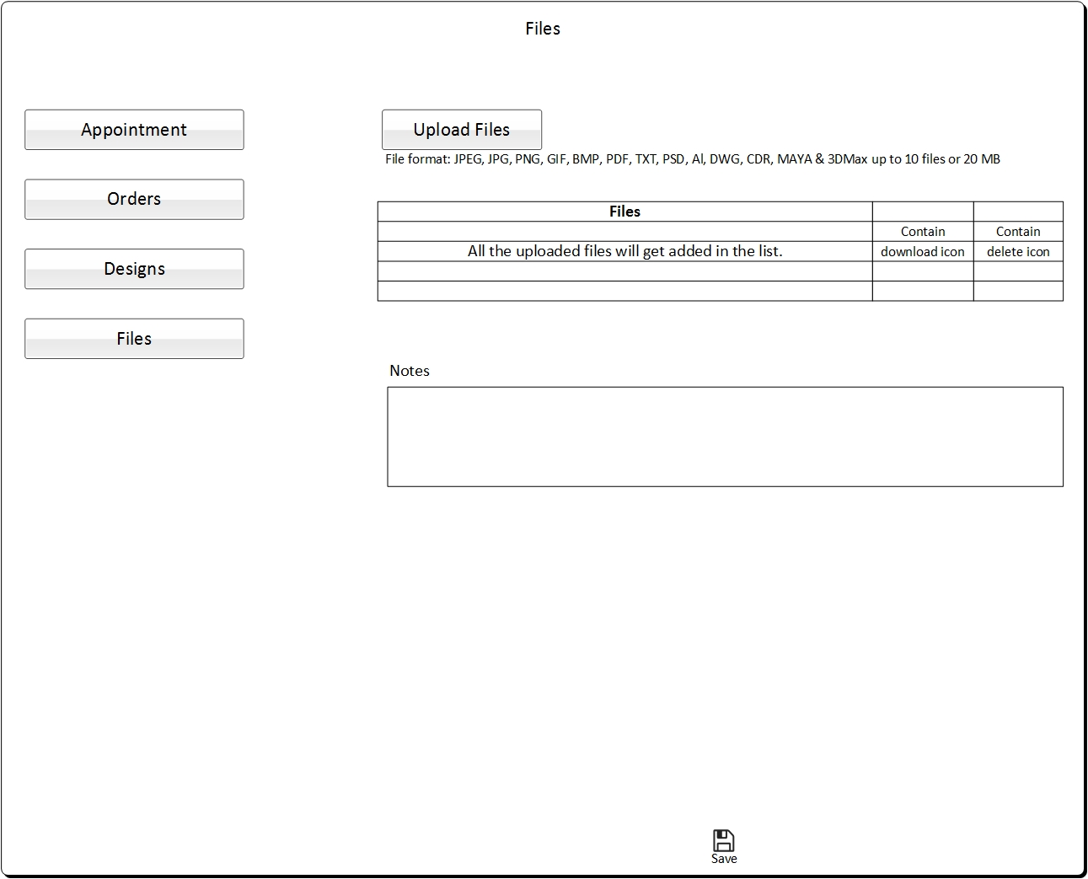

**Figure** *Customer Web App - Files*

* + 1. Appointments
* A list page will be present which contains all the appointments scheduled by the respective customer.



**Figure** *Customer Web App - Appointments*

* From list and also from landing page, customer will get redirected to Appointment Detail page.
* There are 4 statuses for appointments:
* **Appointment status - Scheduled:**

Cancel action is available in case of scheduled status i.e. customer can cancel the appointment from appointment detail page when appointment’s status is scheduled.



**Figure** *Customer Web App – Appointment Detail_1 (Mock up – updated: 04/25/2017)*

When customer cancels the appointment, he/she needs to enter the reason. The reason for canceling the appointment is optional not mandatory.

* Designer will enter the “Meeting link” in the respective Appointment Detail form (Designer portal), which customer can only click to initiate the Skype call with the designer.
* This “Meeting Link” will be present/enabled in Customer Appointment form as clickable link only by customer in customer portal.
* Designer can also update this meeting link but customer cannot update this meeting link. Customer can only click this link to initiate Skype call at the allotted time slot.

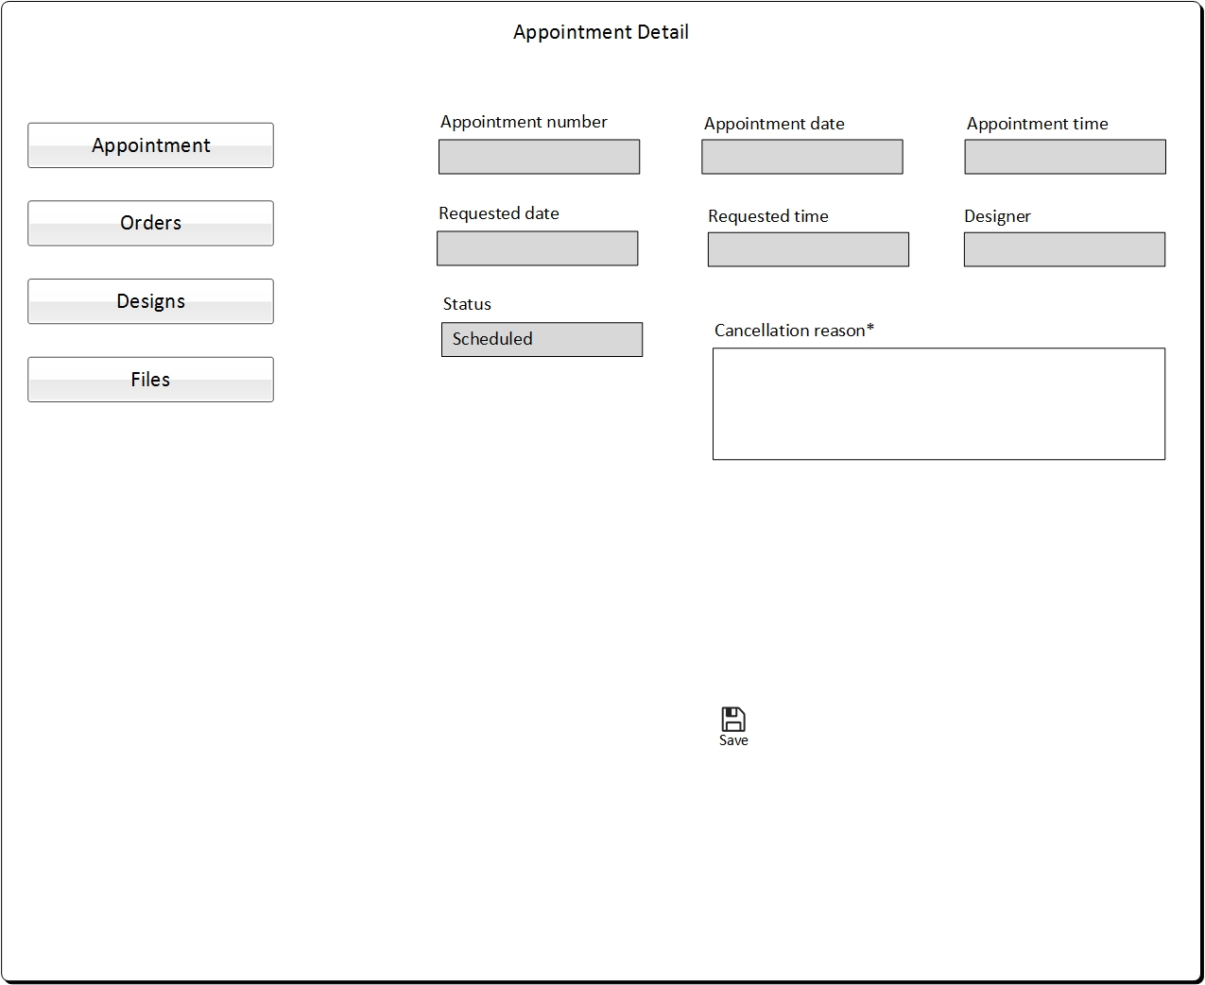

**Figure** *Customer Web App – Appointment Detail_2*

* **Appointment status - Initiated:**

When Designer initiates the appointment then the appointment status changes to Initiated. Appointment is available in read only state.

**Note:** If Appointment is remained at “Initiated state” but design uploaded by designer. Designer must manually update the status as “Complete” so that Customer can have access on to the Designs to purchase it. (this issue has been resolved now). Complete Call button will now remain as Enabled. Earlier, it was getting hidden after Appointment End time passed out.

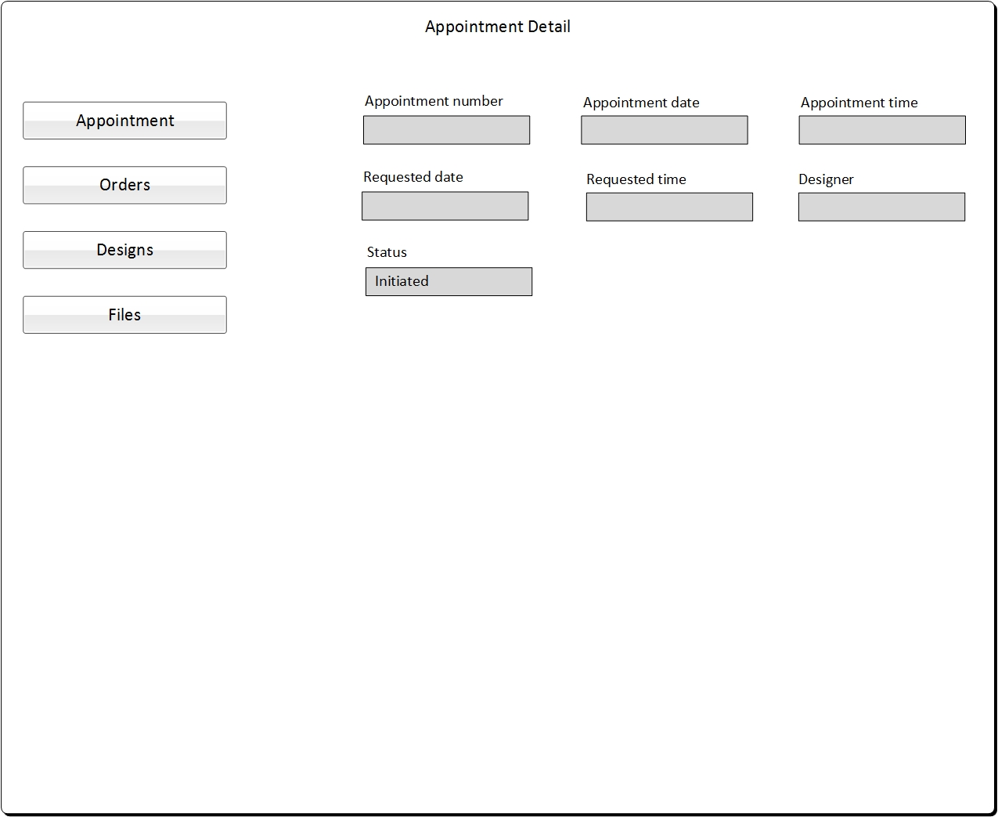

**Figure** *Customer Web App – Appointment Detail_3*

* **Appointment status - Cancelled:**

Appointment is available in read only state.

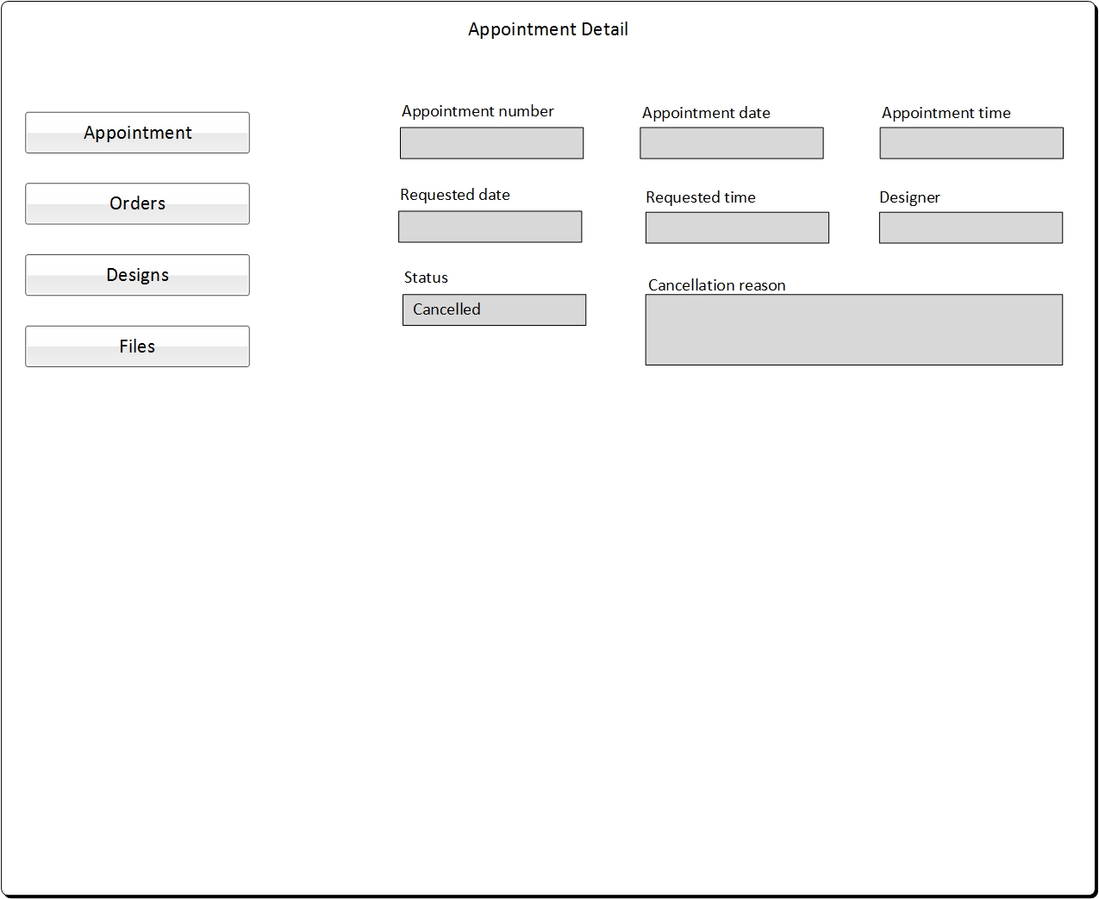

**Figure** *Customer Web App – Appointment Detail_4*

* **Appointment status - Completed:**

When the appointment is completed and the designer uploads the design in Customer account then the status changes to Completed state. Also Design number and Design image will be present in Appointment detail.

Also BUY button is present, upon clicking this button customer gets redirected to Order page.



**Figure** *Customer Web App – Appointment Detail_5 (Updated: 06-01-2017)*

* + 1. Customer placing Call Request
* Customer can place a call request from designer.
* For one time-slot of a day, customer cannot place multiple call requests i.e. only one call request for one time-slot is allowed.

There are two connection options available:

1. **Option – 1 Connect Now**

* “Check In” to be called by the Designer
* Customer tries to connect with the Designer by clicking the “Connect Now” from the appointment list page or landing page. This will place the customer request to be called back by the software.
* It will have the following details (Name, Email, Phone number - that is stored in profile details).

And Customer will receive the success message in the pop up that “You have been added to the queue. You are number <number # in which they are in the queue will appear> in the queue. Someone will contact you soon.”

* Customer can place one “Connect Now” request at a time till his/her request is not converted into the appointment. If customer tries to place another request, before his request converting in to the appointment then he/she will not be able to place the request and will get the message that “You are already added in the queue”.



**Figure** *Customer Web App – Appointment List*

* If there is no one waiting in line,-a Graphics Designer will see that a customer has checked-in and requested to be called. The designer will select the customer to lock the customer for a call i.e. adds the call request to his/her schedule - so that no other designer will try to call the customer at the same time.
* Once a designer gets the lock successfully he will call the customer. Designer will request customer to join a Live Skype Meeting for the order.
* Designers should be able to see in that line of customers, their Name, email, and phone (information stored in the profile). Once any designer is free and he/she will add schedule for the customer to call and also invite the customer to a Skype Video call.

1. **Option – 2 by booking an appointment on the calendar**

* Customer should be able to book an appointment on the calendar (also to be called back by the designer) with whom the appointment is booked.
* Calendar (visible) on the Web App will include time slots, in 15 minute intervals.
* Customer can view the calendar with slots, select it, and book it.
* Customer can book an appointment on a Calendar which is visible for 2 weeks (out in the future) from the current date.
* Customer firsts selects the date from the Calendar.
* Then the customer selects the slot in the selected date, does not select any preferred designer and clicks search then one of the available designer’s name will appear for the appointment (the back-end system will assign one designer based on the total number of appointments booked in the given day taking into account equal distribution of work-load).
* Customer can continue booking the appointment with the designer whose name has appeared. In case if the customer doesn’t want to continue with the designer whose name appeared then he can click for “More Designers” button. A list of available designers will appear for the selected time slot.
* Customer first selects the designer with whom he wants to book the appointment.
* Once the designer is selected, customer will book the appointment.
* The calendar appointment visible to the Designer should automatically include customers name, phone, and email (that is stored in profile details). Calendar appointments are only for 15 minute slots for each Designer.
* If no Designer has saved their availability time in the calendar (at Designer portal), and if a customer is trying to select a designer at that time, then Customer should be notified with the Message of No designer available for making appointment request of the requested date-time slot. ***Error Message “No Designer is available at the selected time. Please select another time.”***
* Even first time customers need to have the option to pick their own designers

The calendar booking form should ask the question:

* “Do you have a preferred Designer?”
* The default answer setting should be NO.



**Figure** *Customer Web App – Add Calendar Apointment_1*

* If the customer selects YES from the NO/YES drop-down, and customer clicks search then the form will provide with one of the available designer.
* The customer can book the appointment with the appeared designer. But if he wants to book the appointment with some other designer, he will click for More Designer. It will give a list of available designers.



**Figure** *Customer Web App – Add Calendar Apointment_2*

* After selecting the preferred designer, customer will book the appointment.
* Time for appointments in the calendar is in CST time format.
  + 1. Purchase Option
* Once the design is complete, designer will upload the design’s watermarked image in customer’s account.
* List page will be created for all the uploaded design images for the respective customer.
* As soon as the Designer uploads the image, “Buy” button will get enabled for the customer. Customer can see the design and select color size options (from their Account) and get a price of the finished product along with a price to download vector design.
* The pricing will be calculated based upon the size and no. of colors of the sticker.
* The customer can select one or the other INPUT for size.  Either the Length (inches) or the Width (inches) up to 2 decimal points.
* Width (inches) is now renamed as Height (in inches) at Create Order form, Order Detail form, Update Tracking Number forms, Design Details form.
* Based on the aspect ratio, the final size should be determined (calculated) from the formula using aspect ratio for the Length and the Width. Maximum limit for Aspect ratio should be set as ***Minimum Limit 0.001 Maximum Limit is 99.999. 3 digits after decimal point.***
* Using the Final Size, for pricing the product, take the larger number of the two and multiply by the single color/2 color/3 color rate for the final Price of the product.

Below is an example for calculating final price:

If the customer chooses to enter the height eg. 3" the program will need to divide 3 by .256 to determine the length. (3/.256=11.71875) only keep 2 decimal points and round up. So the length that will be displayed to customer will be 11.72" based off of their 3" height input. If the customer chooses to enter the length eg. 8" then the program will need to multiply 8 by .256 to determine the height. (8X.256=2.048) only keep 2 decimals and round up so the customer would see 2.05" as the height.

Aspect Ratio: .256

Customer enters height of 3", Program (3/.256) = 11.72"

Customer enters width of 8", Program (8X.256) = 2.05"

Customer can only specify one dimension, length or width. Program will determine the other dimension.

* In Select Color, the list of colors will include those for which taking orders is allowed.
* Customer has to select at least one color. He/she can select more than one color.

Customer will have **two options** with enabled Buy buttonavailable immediately upon the upload of watermarked image by Designer in his account:

1. One is to purchase the physical sticker by selecting the Color and Size and the other is to purchase the Vector files.
2. Customer can choose to purchase either one or both options.
3. Once vector file is purchased, then customer won’t be allowed to re – order the same vector file. It will always be enabled to download from the Design detail form (in customer account). Hence the option to Purchase vector file will get disabled in re-ordering the same design file.
4. Customer can purchase design sticker multiple times, till master has not deleted respective design file or vector file from the master portal (Customer detail form).

Regardless of whether customer makes any purchase, the customer will be able to see the Exported JPEG Image of the design with the watermark in his/her account.

* If the Customer purchases the Vector file, it will be added to the respective customer account and available to him/her to download.
* Customer and Pro Stickers Designer cannot delete the vector file from there account, it will always be there for future re-download if needed.
* Pro Stickers Master/Admin should be able to delete the vector files from customer’s account. It will also delete the design number from the pro sticker account also. Hence, re-ordering for the deleted design number (also deleted vector file) will not allowed. But if the order(s) status is still placed, then master will also not allowed to delete the design file/vector file.

**Pricing for Vector file:** To start with, Pro Stickers want it to be $30.00 flat fee.

**Pricing for Physical sticker:** As per pricing XLS received from Pro Stickers in case of Predefined size and in case of custom size as per formula.

**Shipping charges** are extra in case of purchase of physical sticker.

* For US: a flat charge of $4.00 needs to be added
* For International shipping: It needs to be calculated from USPS shipping calculator (link below).
  + <https://www.usps.com/business/web-tools-apis/welcome.htm>

**Delivery Address:** By default, complete billing address will appear auto filled in Delivery Address (If added in customer profile).

**Select Color (Form: Create Order)**

* While creating an order, customer should be given the choice to pick up 5 different colors. These color choices should appear in five rows labelled as Color one, Color two, Color three, Color four, Color five. Customer should select each individual color and the row needs to show the selected colors. For e.g., if the customer chooses red color as color 1, then red color need to show in color 1 box. If the customer chooses white for Color 2, then the color 2 box should show white color. Customer should be able to edit and delete any selected colors until the order is placed. The designer will upload an image which will show different COLOR Regions and label them in the image as Color 1, Color2, Color3, Color4, and Color5. This image will be the watermarked image uploaded by designer in the appointment detail form.
* At least one color needs to be selected, and a maximum of five color selection (optional) should be allowed in same order to be created.
* Color Selection will be editable and it can also be deleted till order gets placed (on saving the created order from customer portal)

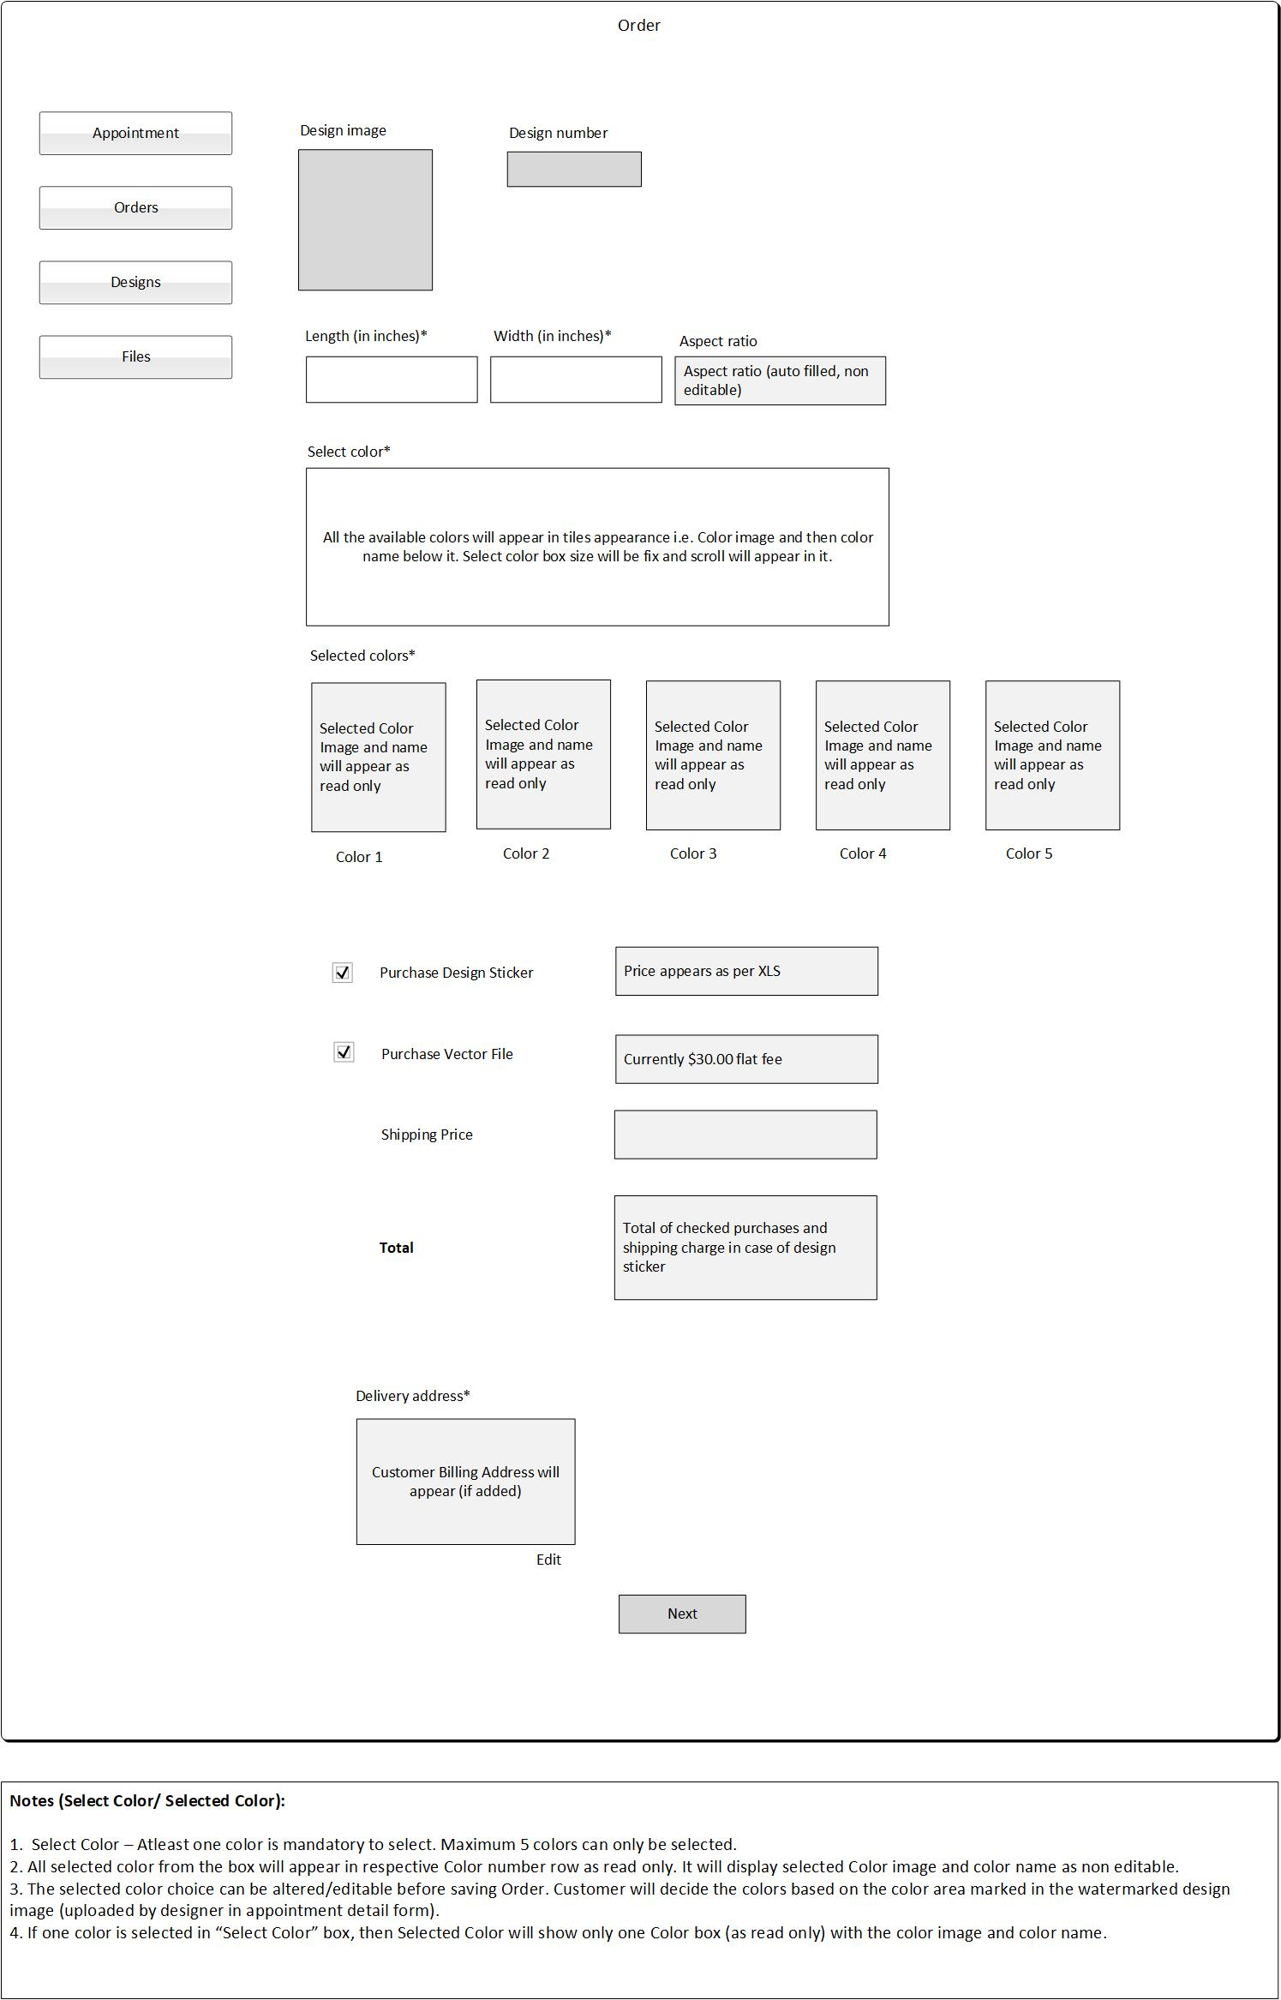

**Figure** *Customer Web App – Order_1 (Mock Up updated: 06/01/2017)*

If billing address is present but customer wants to ship the sticker at other address, or billing address is not added previously then customer needs to add the Delivery Address mandatorily then in both this case, for this customer needs to click Edit link.

If the billing address is present, then it will appear auto filled in address fields on RHS else they will appear empty.

Customer will add the address details and click Add icon. On click of Add icon the added address will appear in Delivery Address box.

Adding this Delivery Address will not update Billing Address in Customer Profile. This added/updated delivery address is for the respective order.

**Design Image is shown in bigger view at –**

* Create Order form
* Design Detail form
* Appointment Detail form
* Order Detail form



**Figure** *Customer Web App – Order_2 (Mock up updated: 06/01/2017)*

On click of Next, customer will be redirected to Payment page.

* + 1. Payment and Shipping Option
* Customer makes the payment online entering his required credit card details using stripe payment gateway.



**Figure** *Customer Web App – Order_3(Updated mock up: 06/01/2017)*

On click of successful payment, customer will get success message.



**Figure** *Customer Web App – Order_4 (Mock Up updated: 06/01/2017)*

* Product is shipped to Customer.
* Customer should be able to track the shipping.
* Delivery confirmation is emailed to customer.
* Have auto generated emails sent once customer orders ships.
  + 1. Design
* A list page will be present which contains all the designs created and uploaded for the respective customer.
* Drill down is present in Design number, on click of which customer will be redirected to Design detail page. Also list will contain Buy button on click of which customer will be redirected to Order page.
* Column “Design image” is added as the first column with Drill down feature. Design number is now Column two and Buy button column is the third column in the Design list page.



**Figure** *Customer Web App – Design List (Updated on: 06-01-2017)*

* Design detail page will contain three buttons:
* **Download Vector File** button will be present if the customer has purchased the vector file previously else it will not appear.
* **Buy** button will be present on click of which the customer will be redirected to Order page.
* **Delete** button will be present on click of which a confirm box will appear saying “Are you sure you want to delete the design?” This deletion by Customer will permanently delete the design files from the Customer/Pro Stickers account. Thus, its respective vector file will still be available for download. (Design number will not be deleted in this case)
* Design Image is shown in bigger view. All fields in this form are arranged in row wise. (one field in one row pattern).



**Figure** *Customer Web App – Design Detail (updated on: 06-01-2017)*

* + 1. Order
* A list page will be present which contains all the orders of the physical stickers.



**Figure** *Customer Web App – Order List*

* Drill down is present in Order number, on click of which customer will be redirected to Order detail page.
* Two status will be present for Order: Placed and Shipped. When order is placed, Status will be “Placed”. When order is processed and the Master/Designer adds the tracking number to the Order then the Order status will be “Shipped”.
* Tracking number and Tracking link will appear in Customer’s Order. Tracking link is present on click of which, customer gets redirected to shipping service URL to track the order shipment. ***Max limit for Tracking number should be 40 alphanumeric characters.***
* Fields such as Length (in inches), Height (in inches), Selected Colors (At Create Order) with Color number – are newly added fields in Order Detail form.
* In Order Detail: Order amount is replaced with the purchased items prices. Such as, Decal Price, Vector file price, Shipping charges, and Total order amount (that is the sum total of all the purchased items).
* If any of the Decal or vector file is not purchased, then respective price amount will not be shown in the corresponding Order Detail page.

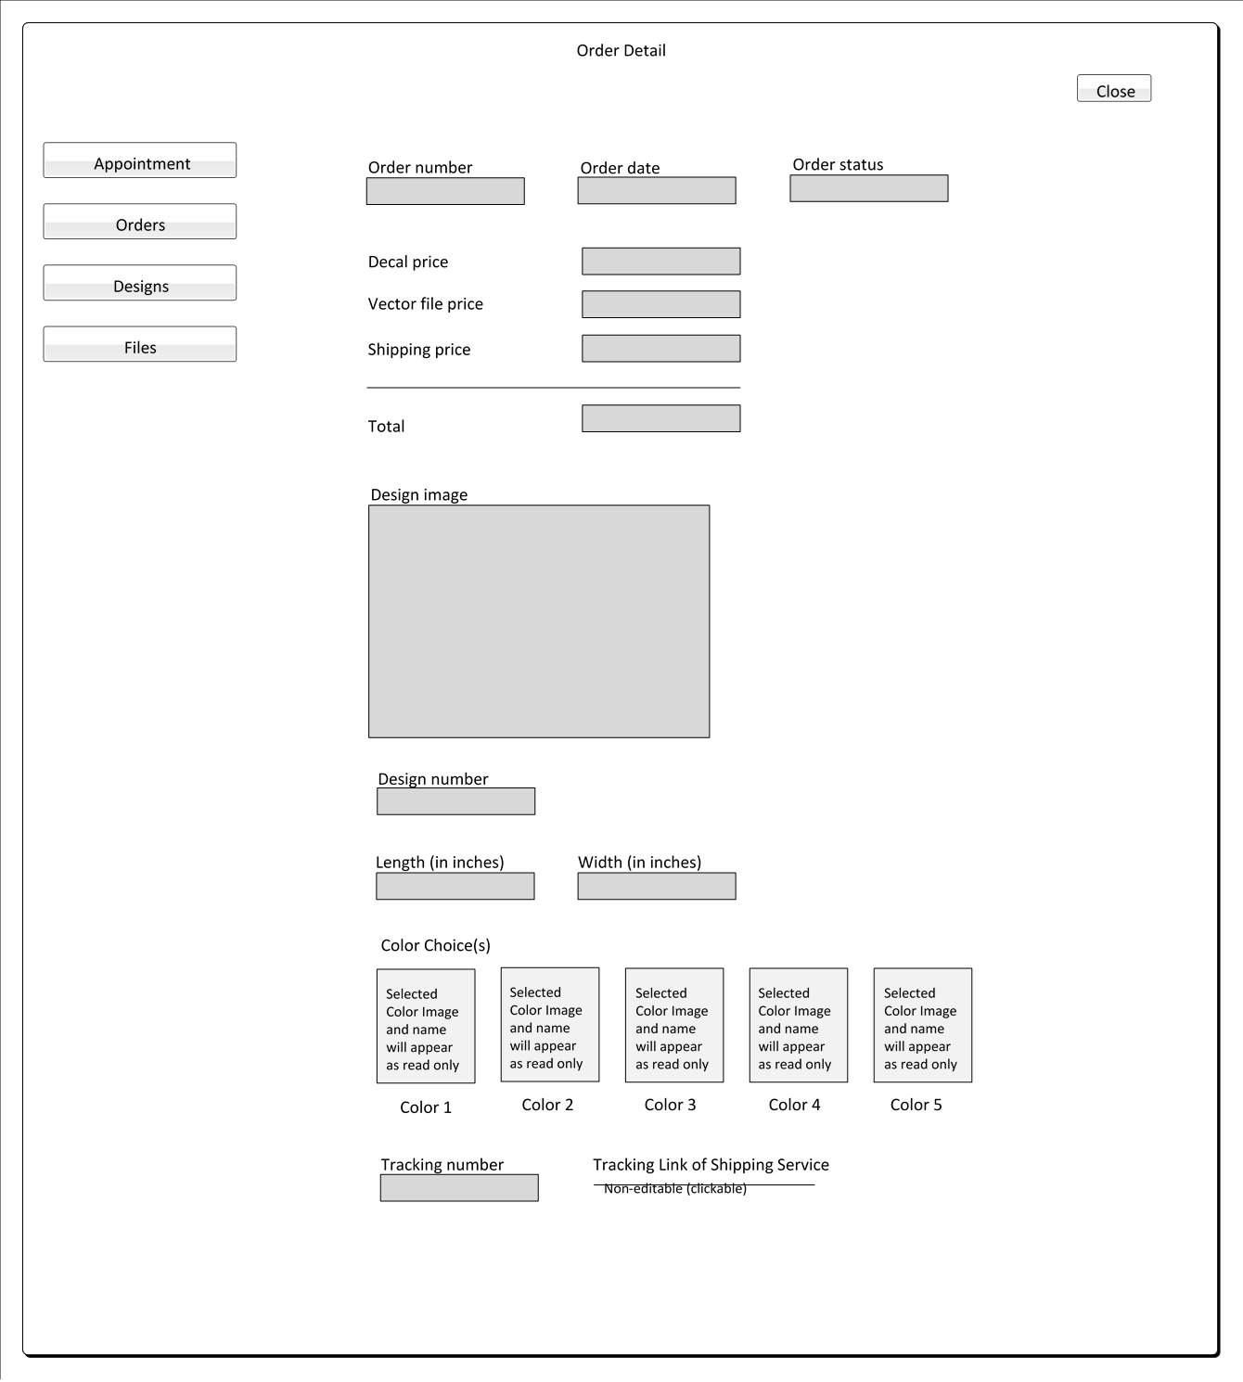

**Figure** *Customer Web App – Order Detail with Tracking Details (Updated on: 06-01-2017)*

* + 1. Feedback Form

After Payment of each order, feedback request is sent to Customer.

Here Customer will give the feedback for Pro Stickers and/or Designer.

* Text box for Reviews/Feedback where customer can add review.

Maximum limit: 500 characters.

Feedback request is Optional. Customer is encouraged to give the feedback, but it is not mandatory. Customer can re-order stickers even without giving any feedback. Feedback request is given only after customer receives finished sticker in mail or customer purchases vector files (design). This feedback request should be sent using email with a link. This feedback will be for the company. Customer needs to sign-in to Pro Stickers Customer Web App to give the feedback.

Once Customer uses the one link to give the feedback then he/she cannot use the same link to give feedback i.e. customer can give one feedback per link.

On click of the link following page of Customer Web App (after sign in) appears:

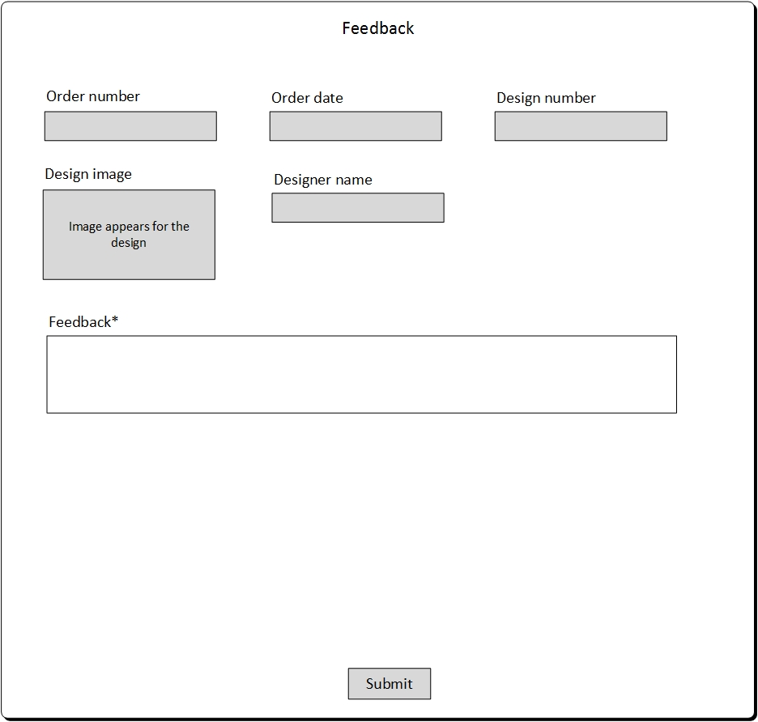

**Figure** *Customer Web App – Feedback*

* + 1. Connect Now button

“Connect Now” button will appear in Public Website:

* On New Customer clicking on Connect Now button from Public Website:
* When new customer comes to Public Website and click on Connect Now button then he/she will be redirected to “Sign In” Page. (3.1.1. - **Figure** *Sign In for Customers)*
* The respective customer needs to sign in from either his/her Google or Facebook account.
* After successful sign in he/she will be redirected to Pro Stickers Service Terms and Privacy Policy Page. (3.1.2. - **Figure** *Pro Stickers Service Terms and Privacy Policy*)
* n successful acceptance and submission of Service Terms and Privacy Policy, Customer will be redirected to “Customer Profile” Page. (3.1.3. – **Figure** *Customer Profile*)
* After saving profile information, customer will be redirected to Landing Page (3.1.4. - **Figure** *Customer Web App Landing Page*) with Success message of Connect Now request. (3.1.4. - **Figure** *Pop up - Contact Me Request Success*)
* Connect Now – will show the real-time Contact request - Queue number. Queue numbers will be updated with those requests which gets scheduled by designer. (Earlier, the request queue number was keep on increasing day wise)
* On existing Customer clicking on Connect Now button from Public Website:
* When existing customer comes to Public Website and click on Connect Now button then he/she will be redirected to “Sign In” Page. (3.1.1. - **Figure** *Sign In for Customers*).
* After successful login, customer will be redirected to Landing Page (3.1.4. - **Figure** *Customer Web App Landing Page*) with Success message of Connect Now request. (3.1.4. - **Figure** *Pop up - Contact Me Request Success*).
* If the existing customer is already in queue and request for “Connect Now” then he/she will get message that he/she is already in queue. (3.1.4. - **Figure** *Pop up - Contact Me Request – Already Added Message*)
  + 1. View Designer Profile

Following Designer Details will appear in Public Website:

* Designer’s Name
* Profile picture

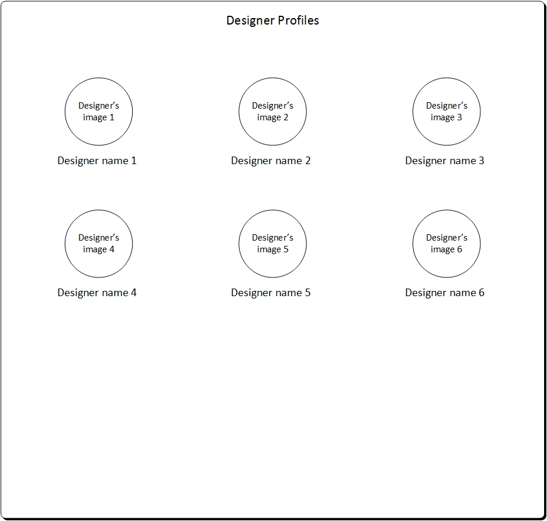

**Figure** *Customer Web App – Designer Details*

* + 1. Feedback Page
* Will appear in Public Website.
* Customer’s feedbacks will appear along with their name, date & time of feedback and Master’s reply.
  + 1. How it Works Page
* Will appear in Public Website.

[TO DO – Content in WordPress Template]

* + 1. Color Choices Page
* Will appear in Public Website.

[TO DO – Content in WordPress Template]

* + 1. About Us Page
* Will appear in Public Website.

[TO DO – Content in WordPress Template]

## Master and Designer Web App

* + 1. Users

Form Available to Role: Master

* Form to Create/Edit/Delete Users.
* Delete User (Change requirement) with Active/Inactive Users (New Requirement)
* Includes two user roles i.e. Master and Designer.
* The first Master that is created for Pro Stickers can never be deleted. Delete icon will never appear for the first created Master.
* Sign in Master cannot delete him/herself.
* In Edit User form, google id and role cannot be changed i.e. they are non-editable.
* The google id i.e. added for the users should be unique. Google id for customers, masters and designers should be unique.

Following information is to be saved in Master/Designer’s Profile:

* Name
* Google id
* Role
* Profile Picture
* Brief Bio/Description
* Skype id in case when role is Designer
  + - 1. **User List:**



**Figure** *Users List (Updated on: 06-01-2017)*

**User – active/inactive**

* Delete Column will be replaced with Checkbox (checked true for active user) and (Checked false for inactive user).
* User list will show all active/ inactive users as read only state.
* Common checkbox (for selecting all) is not required in the User list – column header.

Manish - We should NOT make this read only. Make the buttons Toggle between ACTIVE/INACTIVE with checked it should be Active, When unchecked it should be inactive.

**Add User for Master Role:**

Active checkbox will not appear in Create new USER (Master/Designer) form.

Checkbox “Active” will appear in Edit User form with Checkbox as checked and can be editable.

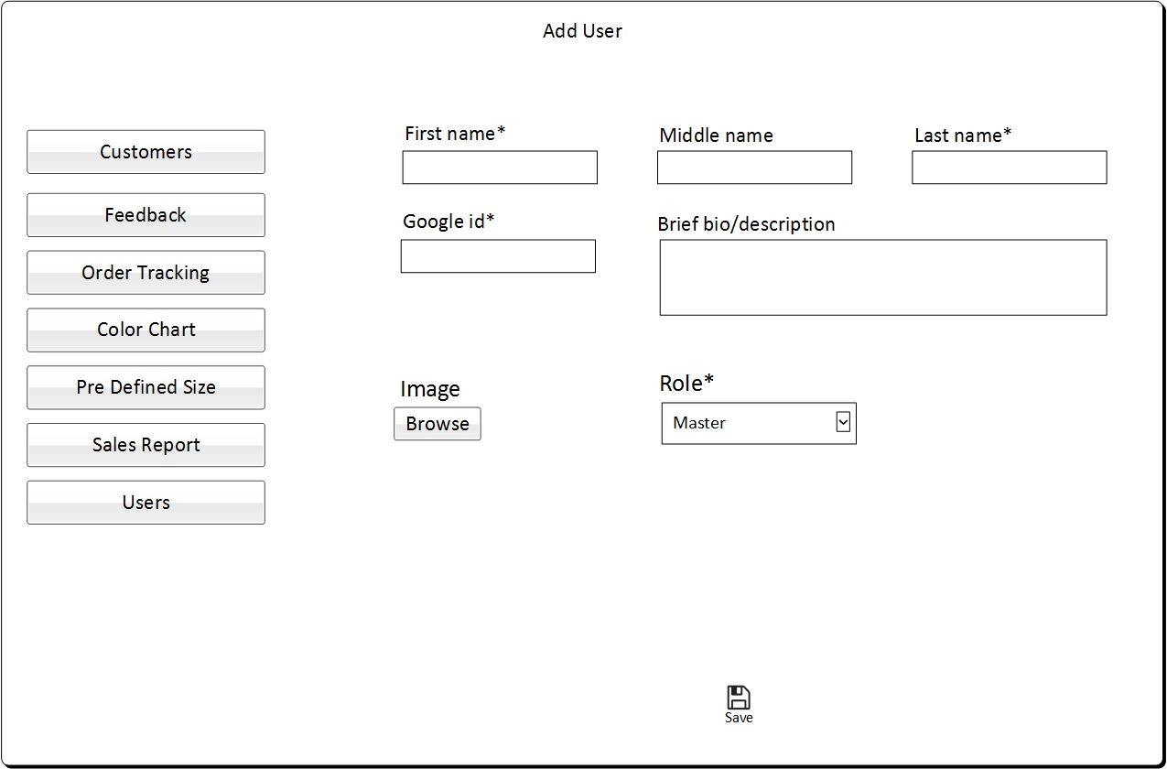

**Figure** *Adding User for Master Role*

**Add User for Designer Role:**

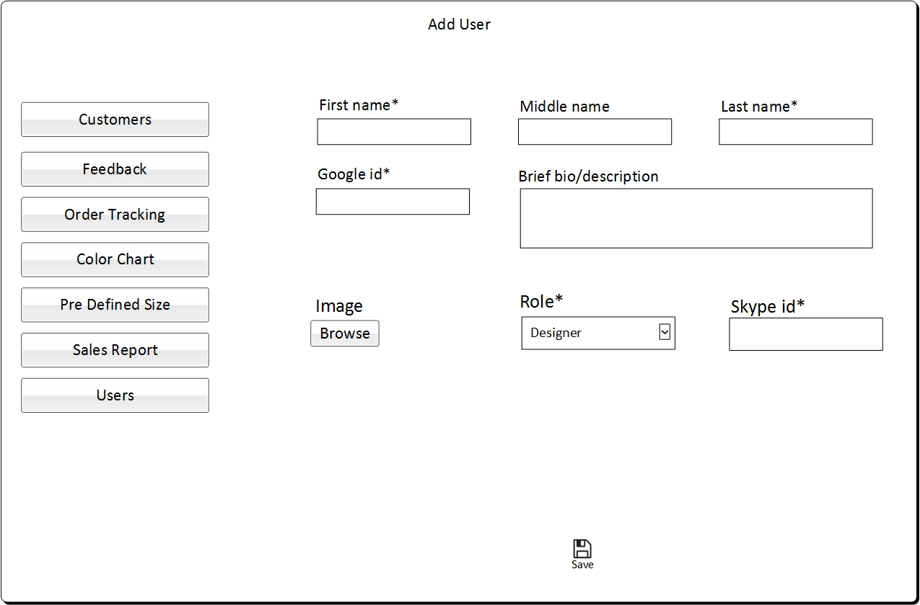

**Figure** *Adding User for Designer Role*

**Edit User for Master Role:**

* Active checkbox (as checked) will appear in Edit User (for Master/Designer) and it can be editable.
* A confirm message box will appear which will ask - ***“Are you sure you want to make the user inactive ~~this user~~?”***(With OK or Cancel option). Success message would be – ***“User updated successfully.”***
* Inactive user (master/designer) can be made active again at any time.All their related data, sales data will still be stored in the storage and can be view in search results at Sales Reports.



**Figure** *Edit User for Master Role (Updated on: 06-01-2017)*

**Edit User for Designer Role:**

* Active checkbox (as checked) will appear in Edit User (for Role: Designer) and it can be editable.
* A confirm message box will appear which will ask - ***“Are you sure you want to make the user inactive ~~this user~~?”***(With OK or Cancel option)
* Success message would be – ***“User updated successfully.”***
* An Error message will also appear, if designer has any scheduled appointments – ***“This user has scheduled appointments, hence it can’t be inactive.”***



**Figure** *Edit User for Designer Role (updated on: 06-01-2017)*

* + 1. Master/Designer Sign In Form
* Master/Designer will sign in through their Google account which is registered in Pro Stickers.

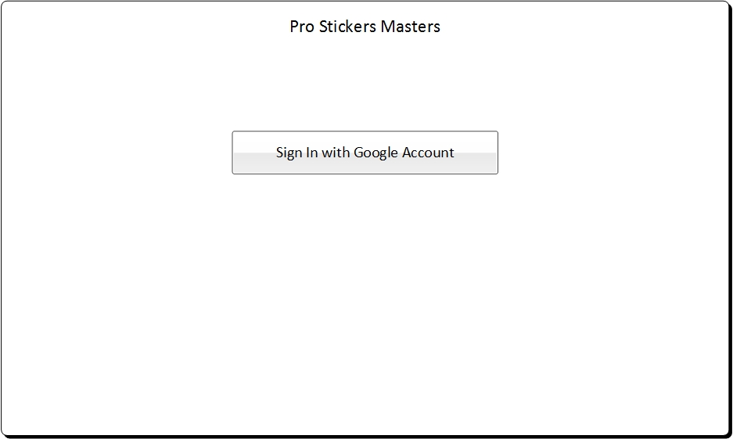

**Figure** *Master/Designer Sign In Form*

* + 1. Landing Page for Master
* Once Master successfully Signs in they will see the landing page and menu items to do all their work.
* Landing for Master will include the most recent 5 feedbacks received from the Customers.
* When Master clicks on View More, he/she will get redirected on list page of Feedbacks.
* Master can drill down from the list of Customers’ feedback to the respective feedback detail.

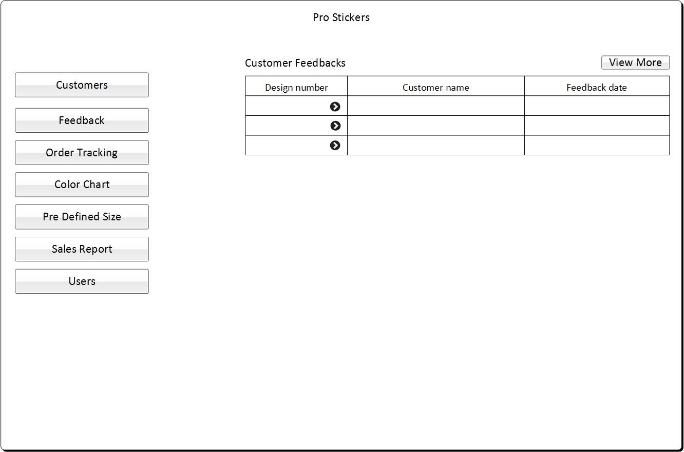

**Figure** *Landing Page for Master*

* + 1. Landing Page for Designer
* Once Designer successfully Signs in they will see the landing page and menu items to do all their work.
* Landing Page for Designer will include all the requested customer appointments of the current day for the respective designers which are yet to be initiated.
* When Designer clicks on View More, he/she will get redirected on list page of Customers’ Appointments.
* Designer can drill down from the list of Customers’ appointments to the respective appointment detail.
* **Landing page for Designer: Top 5 upcoming scheduled appointments will be shown to respective designer in his/her Designer’s home page.**



**Figure** *Landing Page for Designer (updated mock up: 06/01/2017)*

* **Connect Now Requests** as **(Select one for appointment – Clickable link)**
* Connect Now Requests will appear in left menu bar.
* Select one for appointment button is present with Connect Now requests. When clicked on that button, the first Connect Now request can be added to the designer’s schedule.
* First customer’s Connect Now request can be added by the designer in his/her schedule i.e. in FIFO fashion. Any one of the designer can add the respective request to his/her first free schedule.
* When Designer clicks on Select one for appointment then a pop up will appear which will include the first availability appointment date and time slot of the respective designer.

Either Designer can change the schedule date and time of the appointment or save the date and time that appeared.

* On save, the call request will get added to the respective designer’s and customer’s appointment schedule with the saved appointment date and time. And the respective request will get removed from the Connect Now Requests list of the designers i.e. on successful adding of appointment, list will get refreshed for all the Connect Now requests of all the designers.
* When any designer’s appointment finishes before completion of the 15 minutes’ slot and he/she gets free then he/she can add new Connect Now Request in his schedule for the same 15 minutes slot.



*Figure: Select one for Appointment #no (Updated on: 06/01/2017)*

**Pop up to add appointment**

* The Pop up is enabled with a **Timer of 45 seconds**.
* Once a Designer picks a Connect Now request, Count will reduce temporarily till request is saved as “Scheduled”. So that, no other designer can pick the same Connect Now request at the same time.
* If the Request picked by Designer is saved with appropriate Appointment Date and time slot, then this Request will be saved as a Scheduled Appointment. It will permanently reduce the count in “Select one for Appointment” link.
* If Designer don’t save this request or closes the Pop Up (within 45 seconds) without assigning any date or time slot, then the Count will again reset so that any other Designer can pick the same Connect Now request.



**Figure** *Pop up to select one call request for appointment (Mock up updated: 06/01/2017)*

* + 1. Add Availability Time

Form Available to Role: Designer

* Form is required to determine the availability status of the Designer.
* Designer will add the availability time slots.
* Also the time he/she adds is in CST time format.
* In a single day, the designer can add multiple available time slots.
* Designer can also remove the added availability time slots only in case if no appointment is schedule in the respective time slot.
* If once the customer adds the available time slot and there is an appointment scheduled for the respective time slot then when the designer search for the respective date to update the time slots. Then in this case, the time slots for which the appointment is booked will appear checked and disabled. Customer cannot uncheck the booked time slots.
* If a Designer takes leave on a working day then firstly he/she needs to cancel all the appointments of that particular day. After cancelling the appointments, the designer has to uncheck the working availability schedule of the respective day and save it.

(**Note added on 04/25/2017**: this is the only way for an absent Designer, hence currently Master has no access to assign the scheduled appointment to any other Designer)

* Initially 40 time slots will be appearing i.e. from 10 AM to 8 PM. If the designer wants to view the time slot of complete day then he/she needs to select the option View 24-hour slot.
* Either Designer can view slots from 10 AM to 8 PM or 24 hours’ slot.
* Each availability slot will be of 15 minutes. For a day, i.e. 24 hours there will be 96 slots.



**Figure** *Add Availability Time (Mock up updated: 06/01/2017)*

* + 1. Customer’s Appointments

Form Available to Role: Designer

* View/Cancel Appointments
* Ability for Designer to view the Customer’s appointments requested for them, so that the Designer can initiate the call with the Customer.
* If a Designer takes leave on a working day then firstly he/she needs to cancel all the appointments of that particular day. After cancelling the appointments, the designer has to delete the working availability schedule of the respective day.
* For Designers, Customer appointment list will contain two filters i.e. Date dropdown which will have Today, Tomorrow, Next 7 days, Next 14 days, Yesterday and Last 7 days. Default selected date filter will be Today. And Status will contain Scheduled, Initiated, Cancelled, Completed and All. Default selected status will be Scheduled.
* From the Customer Appointments List, Designer can drill down and view the Customer Appointment Details along with Customer Profile.



**Figure** *Customer Appointments List*

* Update Call Information.
* Time added in Pro Stickers is in CST time format.
* Designer will initiate the call with Customer and update the call start time in the system. Also Designer will himself end the call with Customer and update the call end time in the system.
* Designer can enter and edit “meeting link” in the appointment detail form. Customer can click this link to initiate the Skype Call.
* After the Designer connects with the customer i.e. the Designer start a Skype Call and invite the customer to Skype meeting online. The Designer will then work with the customer to finish the design within 15 minutes (As each project is anticipated to last no more than 15 minutes).
* Provide access to Designer so that they can access the respective customer’s account with whom they are having the scheduled 15 minutes call, else designer cannot access customer account directly. Customer’s Skype ID will be shown as read only to Designer’s Appointment Detail form.
* Each design image and vector file will have unique id name and will be saved in customer account with the id name including respective customer’s id followed by year month date and time stamp. This year, month, date and time stamp is the one at which the designer has finished and uploaded the design. Aspect ratio of the vector file is always required whenever designer uploads new vector file.
* Designer can add his own note in the textbox “Designer’s note”. Maximum limit will be 1500 characters. Other master/designer can view/edit this designer’s note also. It would be invisible to customers.
* Designer can also view/edit – other designer’s note from Designs list (previous designs uploaded by same or different designer for the same customer) by Drill down to a separate new page with save and cancel action always enabled.
* Once designer is done creating customer's design, the designer will input the aspect ratio which is determined by dividing the height of the design by the length of the design.
* Any Designer can add files to back-end/server/storage of customer accounts so that they are not visible to customer i.e. through **“Upload Other Files”** i.e. other files not visible to customers.
* Initially Customer Profile will appear collapsed. In order to view, the customer profile, Designer can expand the Customer Profile section.
* From Appointment Details’ Customer Profile, Designer can download the files uploaded by customer and also download the design and vector files present in customer account.
* File format (naming) is updated after change requirement for better recognition of other files.

“**DesignerCode-Date (YYYYMMDD)-Time(HHMMSS)-File name. file extension**”

* **Status – Scheduled**
* When status is scheduled, two actions are possible.

One is to “Initiate” the call and other is to “Cancel” the call.



**Figure** *Status Scheduled (Mock up updated: 04/25/2017)*



**Figure** *Designer’s note (Mock up Added: 04/25/2017)*

**Designer’s note Form Access to: Designer/Master**

* It is a new form which will be drill down from Designs list in Appointment Detail form (Designer Portal) and Customer Detail form (Master Portal).
* Designer note for all the old designs (or previous appointments with the same customer) can be viewed by any Designer/Master (Designs list in Customer Detail form in Master Portal) with Save and Cancel (as a close button) actions enabled to master/designers only.
* Designer’s note will not be accessible/visible to any customer as it is only for internal use.
* **Status – Initiated**
* When Designer clicks on “Initiate Call” button then pop up opens having Call Start Time prefilled as per the slot start time. Designer can add the same pre filled time or update the time and click ok to add the call start time. Designer needs to add the start time mandatorily in order to initiate the call.

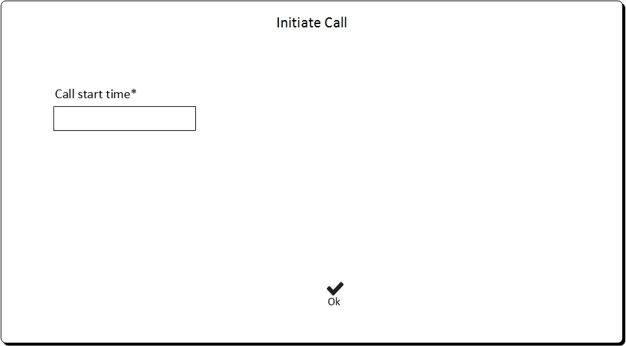

**Figure** *Add Call Start Time*

* On completion of the call, when Designer clicks on “Complete Call” button then pop up opens having Call End Time prefilled as per the slot end time. Designer can add the same pre filled time or update the time and click ok to add the call end time. Designer needs to add the call end time mandatorily in order to complete the call. Call End Time should be less than Call Start Time.



**Figure** *Status Initiated (Updated mock up: 04/25/2017)*

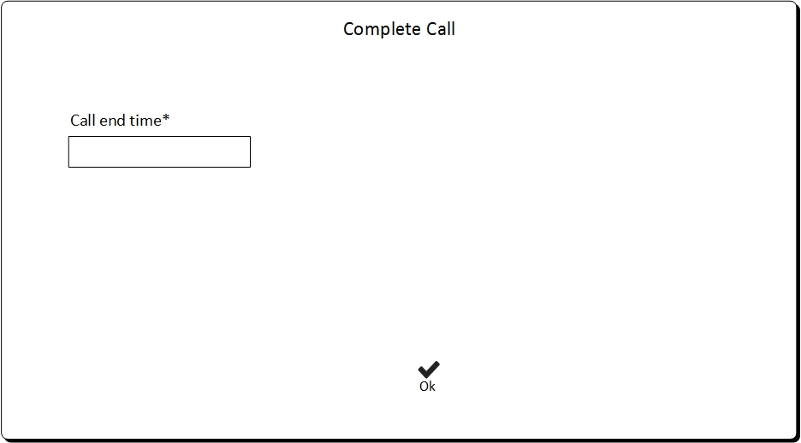

**Figure** *Add Call End Time*

* On Saving of Customer Appointment along with Call start and end time, appointment status changes to Completed.
* **Status – Completed**



**Figure** *Status Completed (updated on: 04/25/2017)*

* **Status – Cancelled**

When Designer cancels the appointment then he/she has to enter the reason of cancellation. A Cancellation Email will be sent to respective customer along with the reason entered by the Designer.



**Figure** *Cancellation Reason*



**Figure** *Status Cancelled (updated mock up: 04/25/2017)*

* + 1. Customers

Form Available to Role: Master

* View/access customers account
* Any Master that accesses customer account will have access rights to the uploaded files and notes/comments for the respective customer with the exception of anything payment related such as saved credit card information.

As per above details of Customer profile/information we are not saving any Credit or Debit Card information. We will be using Stripe Payment Gateway and account through which we will be creating the Stripe Payment Gateway login, through this login Pro Stickers Staff (Master) who has access can go and view the Credit or Debit Card information of the Customer in Stripe not in Pro Sticker’s Customer account.

* These access rights include read and update. No need to limit editing.

Master may need to make changes to customer provided files.

There will be no versioning mechanisms for each update on customer provided documents/files and notes/comments because each project is anticipated to last no more than 15 minutes.

* Back-end software just need to keep the log of which designer worked on the design and when with the customer.
* Any Master can add files to back-end/server/storage of customer accounts so that they are not visible to customer.

Also, it can be edited/deleted by Master once added by any Master/Designer.

* Maximum limit for all files (design files, vector files, other files not visible to customer etc.): **Max file size is 20MB for all upload/download files.** It is applicable only for Master/ Designer portal. **(no change for customer uploaded files – max limit validation)**

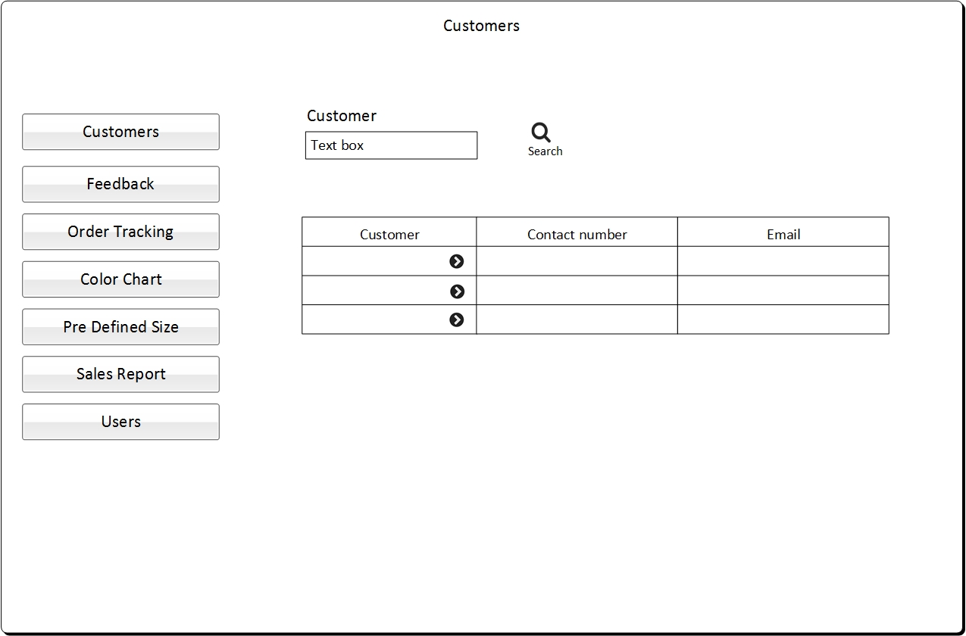

**Figure** *Customers List*



**Figure** *Customer Detail (Mock up updated: 06/01/2017)*

Field such as – Location/Person name, Neigborhood are now removed. Country drop down is set as first field in billing address section in Customer Detail form.

* + 1. Order Tracking Information

Form Available to Role: Master

* Ability to add tracking information to customer accounts.
* Master can update the order tracking number for the orders of physical stickers that are placed.
* Shipping service is USPS.
* When tracking number is added to the order then order status change to Shipped.
* Whenever order tracking number is updated and saved, the delivery confirmation is emailed to customer for the respective order.
* Auto generated email will be sent once the customer order ships.
* On list page Status filter will contain Placed, Shipped and All. By default filter will contain Placed.
* Two more search filters as Date Pickers “Date From” and “Date To” are required with Current date as autofilled which can be editable and These Date pickers will be mandatory search filters (it is required at both master/designer – order tracking number list page).
* Customer as autocomplete but optional in search is required. (it is required at both master/designer – order tracking number list page).



**Figure** *Masters – Order Tracking List (Mock Up updated: 04/25/2017)*

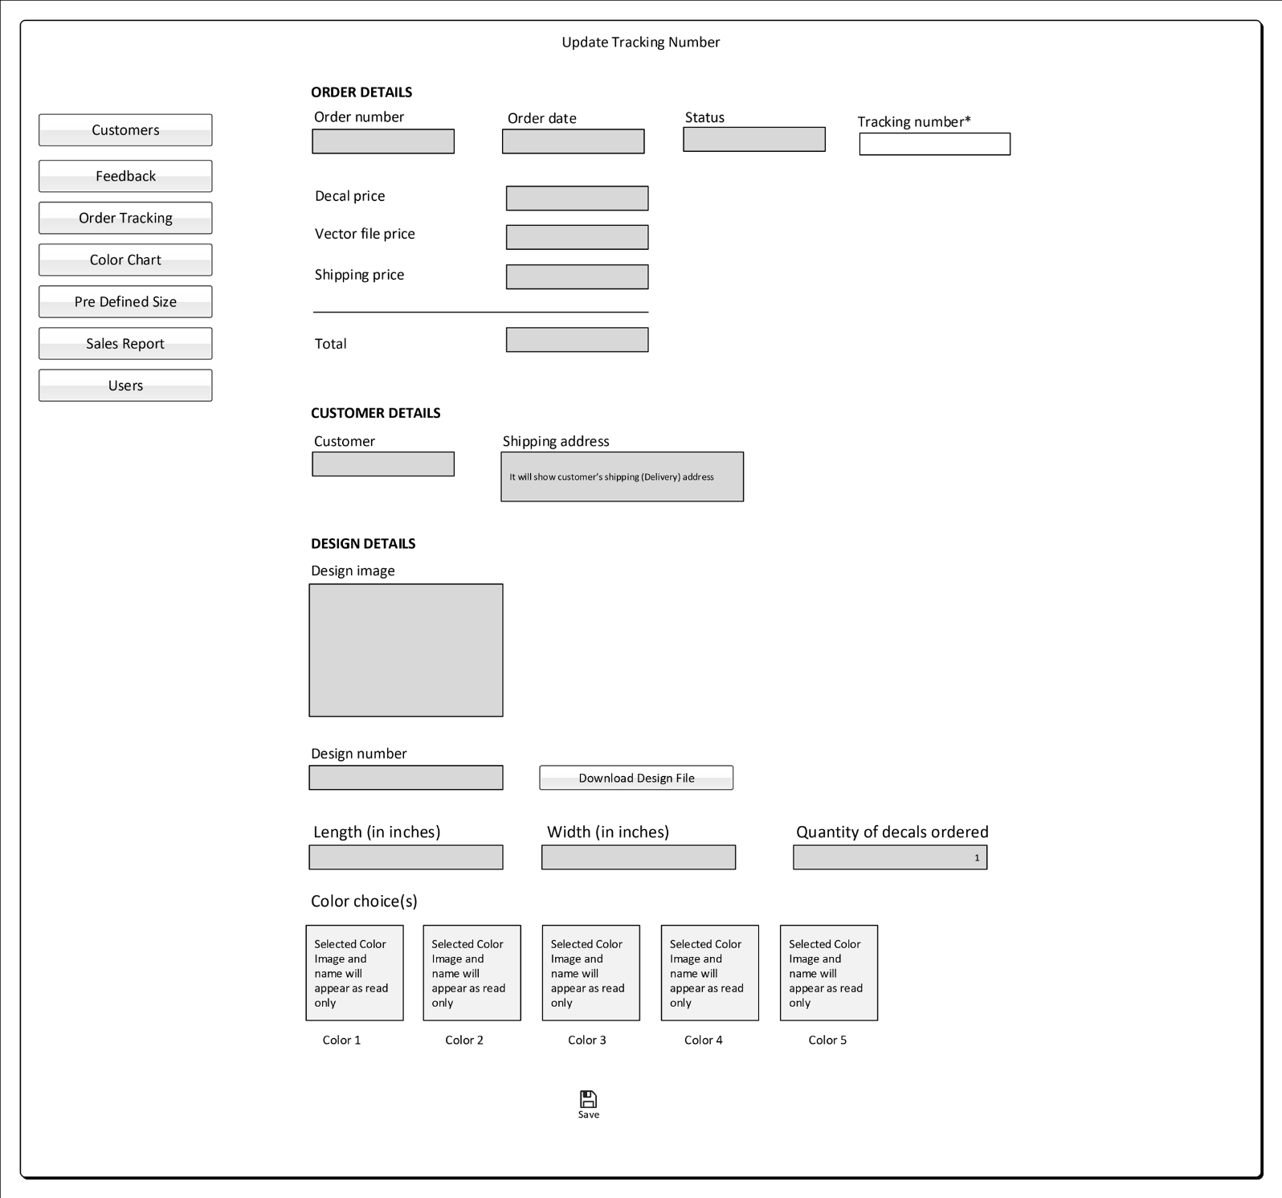

**Figure** *Masters – Order Tracking Detail (Mock up updated on: 06/01/2017)*

**Change Requirement (16-05-2017)**

Following Fields have been added in **Update Tracking Number** form (Access to Master/Designer users) after Change Requirement as:

* **ORDER DETAILS**

1. Order number,
2. Order date,
3. Order Status,
4. Tracking Number
5. Order amount is now shown with individual purchased items prices as mentioned below: (Refer above Mock up: *Masters – Order Tracking Detail)*

* Decal price, Vector file price, Shipping price, and Total

* **CUSTOMER DETAILS**

1. Customer name,
2. Shipping Address

* **DESIGN DETAILS**

1. Design image,
2. Design number,
3. Download Design file button,
4. Length (in inches),
5. Height (in inches),
6. Quantity of decal ordered,
7. Color choice(s)
   * 1. Order Tracking Information

Form Available to Role: Designer

* Ability to add tracking information to customer accounts.
* Designer can update the order tracking number for the orders of physical stickers that are placed.
* Shipping service is USPS.
* When tracking number is added to the order then order status change to Shipped.
* Whenever order tracking number is updated and saved, the delivery confirmation is emailed to customer for the respective order.
* Auto generated email will be sent once the customer order ships.
* On list page Status filter will contain Placed, Shipped and All. By default filter will contain Placed.
* List page of Designer will contain one more filter criterion i.e. Display all designers order. When checked on it and searched will display the order of all designers.
* Maximum limit for tracking number should be 40 alphanumeric characters (for both master/designer – Update Tracking number edit form)
* Display all designer order checkbox will include all Inactive Designers also.



**Figure** *Designer – Order Tracking List (Updated Mock up: 06/01/2017 )*

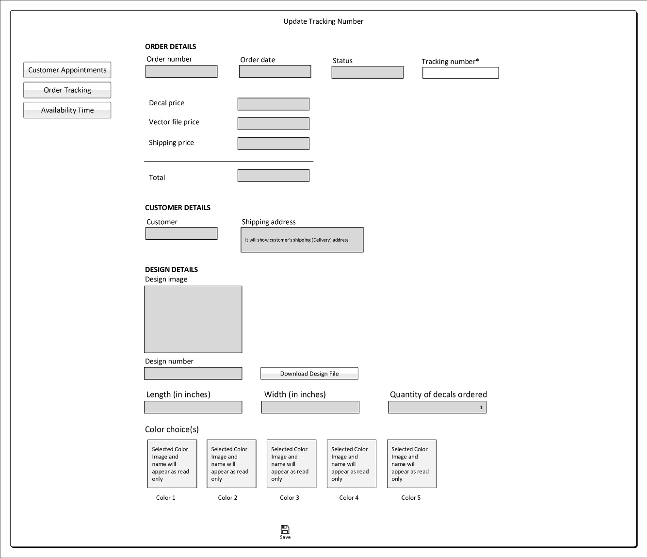

**Figure** *Designer – Order Tracking Detail (Mock up updated on: 06/01/2017)*

In Designer portal, Update Tracking number form: Order amount is now replaced with individual purchased items prices as mentioned below: (Refer above Mock up: *Designer– Order Tracking Detail)*

* Decal price, Vector file price, Shipping price, and Total
  + 1. Feedback Form

Form Available to Role: Master

* Feedback list will contain the feedback received from the customer.
* Feedback list will contain the filters of date from, date to and Customer.
* Date from and Date to will contain current date by default and can be changed. Customer is text box filter.
* This feedback will be for the company. Pro Sticker Masters should have the ability to Respond to each feedback and post it online on their website i.e. made visible to the public. By default for any of the feedback, the box will appear unchecked for Displaying in Public Website. Master can choose whether to display the feedback in Public Website or not by checking/unchecking the box for Display in Public Website.
* If there is some feedback that is offensive, Pro Sticker Master should be able to delete the feedback. Feedback should be shown with the date it was left with the customer’s first name and Last Initial (who left the feedback).
* Also the Master can update the feedback’s reply. Drill down from the list page will redirect to Feedback Detail page.

**Feedback List**

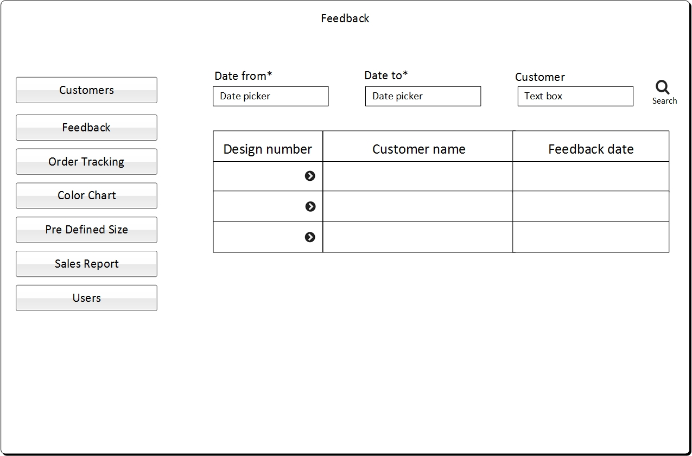

**Figure** *Feedback List*

**Feedback Update/Delete**

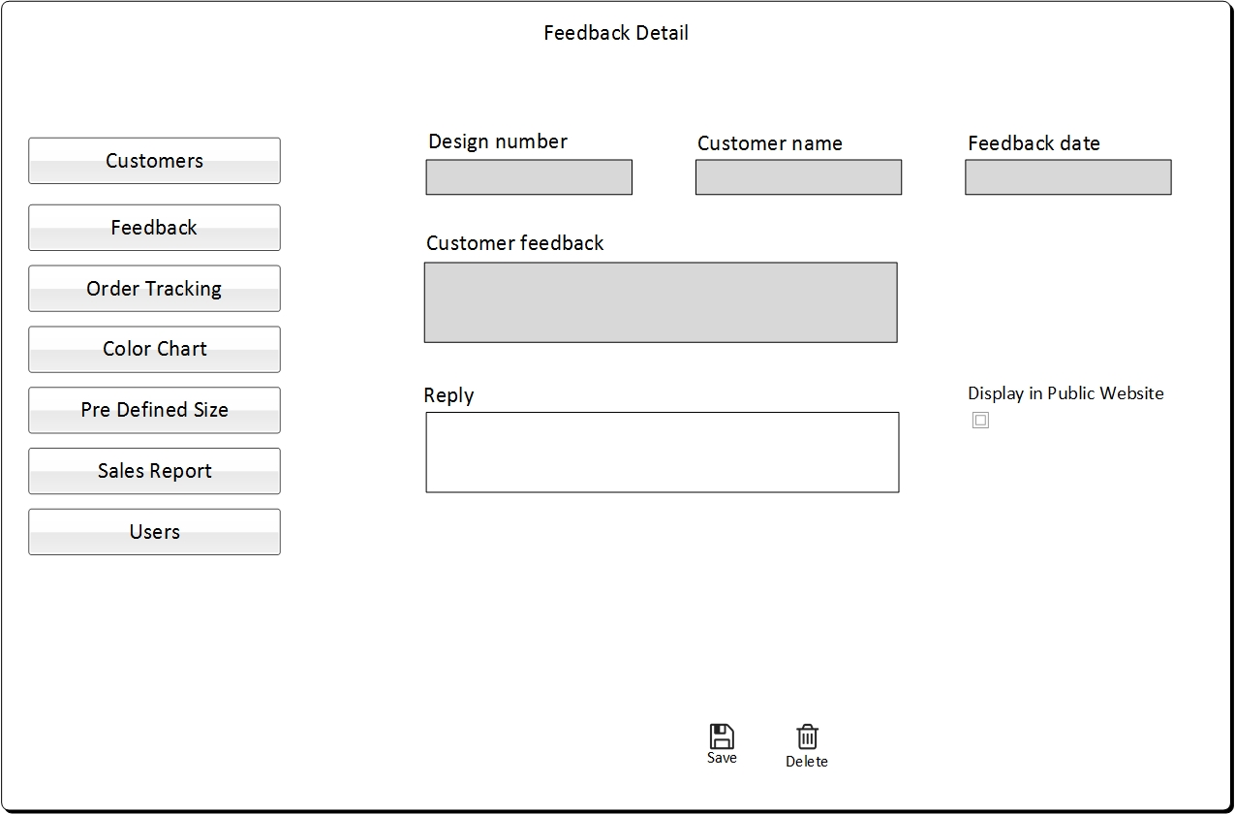

**Figure** *Feedback Update/Delete*

* + 1. Sales reporting functionalities

Form Available to Role: Master

Following reports are expected for sales functionality:

* Ability to see what sales are generated by each Designer i.e. Sales, number of designs created for customers.
* Every time a customer makes a new purchase or re-orders from their account that sale should be associated with the designer that created the artwork.
* If customer has changes made by a different designer, then future purchases would be associated with the designer that made the changes. These changed designs will be saved with new design ids in the customer account.

We will be encouraging our designers to build up a clientele and customer base and maintain customer relations and fill their calendar with appointments.

* Report contains filters: Date from and date to will contain current date by default and can be changed. Designer drop down will contain the names of all the designers. Default value for Designer drop down will be all and can be changed.
* One more column is required as “Number of design orders” which will show the total order created for all the designs made by respective designer.
* Designer drop down will also contain Inactive Designers also. And search results will also give sales related data for inactive designers.



**Figure** *Sales Report (Mock Up updated on: 04/25/2017)*

* + 1. Product Color Chart

Form Available to Role: Master

* Need self-service/programmable functionality of Color Chart similar to the one shown in www.emblemoverlays.com.
* Master should be able to upload new colors and the price associated with each color, read only color chart for designer.
* Also Master can update the added colors.
* Uploaded color names should be unique.
* It needs to have the option to temporarily assign a color as “Out of Stock”.
* It also needs to have the option of showing when the color will be available or temporarily stop taking orders with the Out of Stock Color.
* If it is known when the color will be back in stock on a future date, then there should be an option for customers to place the order and wait for a longer delivery time.

**Color Chart – List**

* Delete column needed with “delete” icon for every color that has not been used in any placed orders. On click “delete”, a confirm box should appear which will ask “Do you want to delete this color?”
* Allow taking order should also be editable on the Color Chart list.
* Price column is not required in the Color Chart list, create, and edit forms as this price is not considered in calculating final pricing at create order form.



**Figure** *Color Chart - List for Master (Mock Up updated on: 06/01/2017)*

**Color Chart - Add/Edit**

* Price field is not required at Add Color form.
* Price field is not required at Edit Color form.
* Delete button is required at Edit Color form. On click “Delete” button, a confirm box will appear.



**Figure** *Color Chart Add/Update (Updated mock up on: 04/25/2017)*

* + 1. Product Size

Form Available to Role: Master

The pricing for one color is $2 per inch, for two colors is $3 per inch and for three or more colors is $4 per inch. This prices should editable from Master Web APP.

Master should allow to change the per inch price for different colors.



**Figure** *Pre-Defined Price (Mock Up added on: 06/01/2017)*

* **Pricing for Vector file:** To start with, Pro Stickers want it to be $30.00 flat fee. Pro-Stickers Admin should be able to set and change this pricing at any time (It is set by Admin).
* **Pricing for Physical sticker:** As per given in the section 3.1.9

# WordPress Template

WordPress template will be provided to Pro Stickers so they can add the content of the following public pages themselves.

## How it Works

## About Us